UNITED STATES

SECURITIES AND EXCHANGE COMMISSION
WASHINGTON, D.C. 20549

FORM 6-K

REPORT OF FOREIGN PRIVATE ISSUER PURSUANT TO RULE 13a-16 OR 15d-16 UNDER THE SECURITIES EXCHANGE ACT OF 1934

For the Month of February 2021

Commission File Number: 001-39621

OPTHEA LIMITED

(Translation of registrant’s name into English)

Level 4

650 Chapel Street

South Yarra, Victoria 3141

Australia

(Address of principal executive offices)

Indicate by check mark whether the registrant files or will file annual reports under cover of Form 20-F or Form 40-F.

Form 20-F ☒ Form 40-F ☐

Indicate by check mark if the registrant is submitting the Form 6-K in paper as permitted by Regulation S-T Rule 101(b)(1): ☐

Indicate by check mark if the registrant is submitting the Form 6-K in paper as permitted by Regulation S-T Rule 101(b)(7): ☐

INCORPORATION BY REFERENCE

This report on Form 6-K shall be deemed to be incorporated by reference into the registration statement on Form S-8 (File No. 333-251052) of Opthea Limited and to be a part thereof from the date on which this report is filed, to the extent not superseded by documents or reports subsequently filed or furnished.

EXHIBITS

Exhibit Description

99.1 Half-year financial report for the six months ended December 31, 2020

SIGNATURES

Pursuant to the requirements of the Securities Exchange Act of 1934, the registrant has duly caused this report to be signed on its behalf by the undersigned, thereunto duly authorized.

OPTHEA LIMITED

Date: February 22, 2021 By: /s/ Michael Tonroe

Michael Tonroe

Chief Financial Officer and Company Secretary

Exhibit 99.1


22 February 2021

HALF-YEAR FINANCIAL REPORT 31 DECEMBER 2020

In accordance with Listing Rule 4.2A, we enclose the Half-Year Financial Report (reviewed) on the consolidated results of Opthea Limited (‘Opthea’ or ‘Group’) for the half-year ended 31 December 2020. The previous corresponding periods are the financial year ended 30 June 2020 and the half-year ended 31 December 2019.

Information in relation to the operational performance, financial performance, cash flows and financial position is included in the attached Appendix 4D Half-Year Financial Report.

This Half-Year Financial Report should be read in conjunction with the Company’s Annual Report for the year ended 30 June 2020.


Mike Tonroe

Company Secretary

Level 4, 650 Chapel Street, South Yarra, Victoria 3141 Australia T +61 (3) 9826 0399
www.opthea.com ABN 32 006 340 567


APPENDIX 4D

HALF-YEAR FINANCIAL REPORT

OPTHEA LIMITED
ABN 32 006 340 567

REPORTING PERIOD: HALF-YEAR ENDED 31 DECEMBER 2020

PREVIOUS CORRESPONDING PERIOD: HALF-YEAR ENDED 31 DECEMBER 2019

INDEX

1. | Results for announcement to the market |  | next page
2. | Financial report:
 | – | Directors’ Report | page 1 of the financial report
 | – | Auditor’s Independence Declaration | page 4 of the financial report
 | – | Financial Statements | pages 5–15 of the financial report
 | – | Directors’ Declaration | page 16 of the financial report
 | – Independent Auditor’s Review Report |  | page 17 of the financial report

This half-year report is to be read in conjunction with the Company’s 2020 Annual Report Note: The financial figures provided are in Australian dollars.

ASX Announcement

22 February 2021

O p t h e a | A P P E N D I X 4 D iii

RESULTS FOR ANNOUNCEMENT TO THE MARKET

The consolidated results of Opthea Limited for the six months ended 31 December 2020 are as follows:

Revenues and results from ordinary activities

 | Change compared to:
 |  | 31/12/2019 |  | 31/12/2020
 |  | % |  | $
Revenues from ordinary activities | Increased | 15 | to | 314,295
Loss from ordinary activities before tax | Loss has increased | 236 | to | 38,505,045
Loss from ordinary activities after tax attributable to members | Loss has increased | 359 | to | 34,982,213

An explanation of the figures reported above are contained in the Directors’ Report under the heading ‘Financial performance’.

SHAREHOLDER DISTRIBUTIONS

No dividends have been paid or declared by the entity since the beginning of the current reporting period.

Consolidated

NTA backing | 31/12/2020 | 30/06/2020
Net tangible asset backing per ordinary security | $0.59 | $0.24

STATUS OF REVIEW OF ACCOUNTS

The financial report for the half-year ended 31 December 2020 has been reviewed. The auditor’s review report is included at page 17 of the financial report.

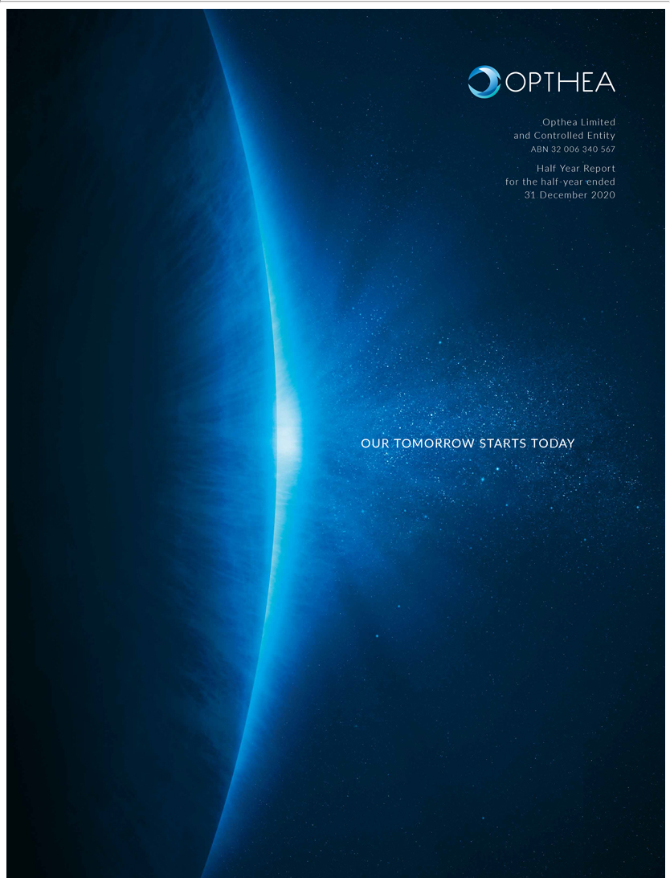

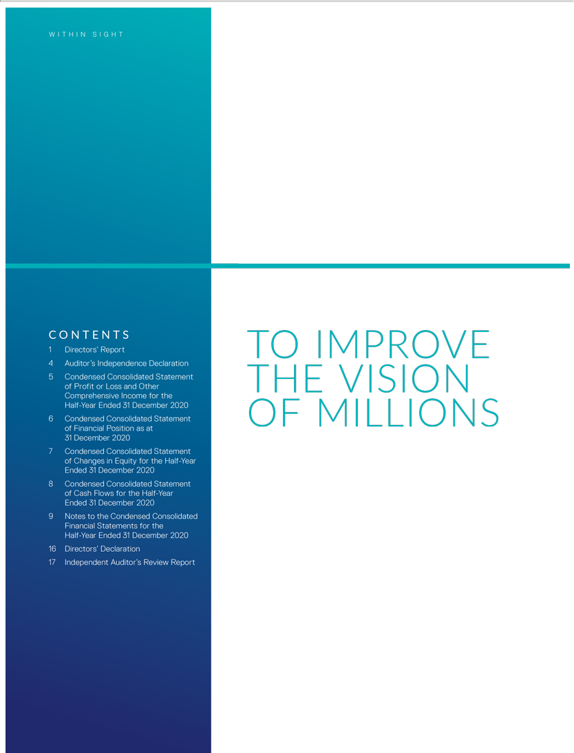

O p t h e a | H A L F Y E A R R E P O R T F O R T H E H A L F - Y E A R E N D E D 3 1 D E C E M B E R 2 0 2 0 | 1

DIRECTORS’ REPORT

The directors of Opthea Limited submit herewith the financial report of Opthea Limited and its subsidiaries (Opthea, the Company and the Group) for the half-year ended 31 December 2020. In order to comply with the provisions of the Corporations Act 2001, the directors report as follows:

DIRECTORS

The names of the Company’s Directors in office during the half-year and until the date of this report are:

Jeremy Levin | Chairman, Non-Executive Director (appointed on 12 October 2020)
Geoffrey Kempler | Chairman, Non-Executive Director (retired on 12 October 2020)
Megan Baldwin | Chief Executive Officer and Managing Director
Michael Sistenich | Non-Executive Director
Lawrence Gozlan | Non-Executive Director (appointed on 24 | July 2020)
Dan Spiegelman | Non-Executive Director (appointed on 10 | September 2020)

OPERATING AND FINANCIAL REVIEW

Financial performance

For the half-year ended 31 December 2020, the Company’s net loss before tax attributable to members is $38,505,045 (31 December 2019: $11,465,210). The increased loss compared to the prior year is mainly due to the increase in research and development (R&D) spending, which can be attributed to the manufacturing of OPT-302 and planning of the Phase 3 clinical trials of OPT-302 in wet AMD.

Set out below are other factors affecting financial performance:

- The total investment in R&D was $18,807,475 (31 December 2019: $8,340,640);

- Net foreign exchange losses were $12,442,849 (31 December 2019: gain of $113,370);

- The net income tax benefit for the half year is $3,522,832 (31 December 2019: $3,845,192); and

- Basic earnings per share were a loss of 11.75 cents (31 December 2019: loss of 3.02 cents).

Financial position

Points to note on the Company’s financial position are:

- The cash position as at 31 December 2020 was $202,544,985 (30 June 2020: $62,020,382);

- The 2020 Research and Development (R&D) tax incentive claim of $8,533,123 was received from the Australian Tax Office during October 2020. A benefit of $3,522,832 (31 December 2019: $3,845,192) has been recognised in relation to the R&D tax incentive in the current period and included in current tax assets;

- During the half year to 31 December 2020, 68,506,400 (31 December 2019: 18,867,930) new shares were issued in a US initial public offering (IPO) and NASDAQ listing, increasing contributed equity by $148,623,205 (31 December 2019: $48,722,444). The Company also issued 7,493,600 pre-funded warrants in the IPO, increasing contributed equity by $16,268,932; and

- As at 31 December 2020, the Net Tangible Asset backing per share was 59 cents (30 June 2020: 24 cents).

Opthea: Company Overview

Opthea is committed to the development of new therapies for the treatment of serious eye diseases that affect the back-of-the-eye, or retina, and lead to vision loss.

Wet (neovascular) age-related macular degeneration (wet AMD) is a progressive, chronic disease of the central retina and in developed nations, is the leading cause of visual impairment in the elderly. Wet AMD is associated with blood vessel dysfunction and proliferation in the macula, a region of the retina which is needed for sharp, central vision. New blood vessels break through layers of the retinal tissue, leaking fluid, lipids and blood, leading to fibrous scarring and loss of vision. Vision loss associated with wet AMD can be rapid and is generally severe, impacting patient independence and contributing to significant healthcare and economic costs worldwide.

Although the underlying cause and biology of wet AMD is complex, inhibition of vascular endothelial growth factor-A, or VEGF-A, has been shown to play an important role in the growth and leakage of vessels associated with the disease, and inhibitors of VEGF-A are now standard of care treatments for wet AMD. The VEGF-A inhibitors ranibizumab (Lucentis®) and aflibercept (Eylea®), approved for the treatment of wet AMD, together generated revenues in excess of 11 billion USD in 2019. Such commercial success reflects the widespread use of the VEGF-A inhibitor class of therapies and the importance that physicians and patients alike attribute to the preservation and improvement of visual acuity for quality of life.

However, despite many patients experiencing gains or stabilisation of vision, at least 45% of patients with wet AMD exhibit a suboptimal response to therapies that selectively target VEGF-A. As such, there remains a very large commercial opportunity for novel therapies that address the unmet medical need for patients who have further room for improvement in visual acuity despite regular administration of currently available therapies.

2

DIRECTORS’ REPORT (CONT.)

OPT-302: Opthea’s Phase 3 ready candidate for the treatment of Wet AMD

Approved therapies for wet AMD block VEGF-A, whereas OPT-302 targets alternative members of the VEGF family of proteins, namely VEGF-C and VEGF-D, that also stimulate blood vessel growth and vascular leakage and are implicated in the progression of retinal diseases.

Opthea is developing OPT-302 as a complementary treatment to be used in conjunction with VEGF-A inhibitors for the treatment of wet AMD and other retinal diseases. By combining administration of OPT-302 with a VEGF-A inhibitor, broader blockade of important signalling pathways that contribute to the pathophysiology of retinal diseases can be achieved, which may improve visual acuity and retinal swelling in patients. In addition, inhibition of VEGF-A results in compensatory upregulation of VEGF-C and VEGF-D that may limit the efficacy of selective VEGF-A inhibitors. OPT-302 blocks this mechanism of resistance to existing therapies which may then result in improved and more durable clinical responses.

Opthea’s lead product candidate OPT-302 is well-differentiated with a key objective to improve clinical efficacy and the potential to also produce more sustained, durable clinical outcomes for patients. The majority of agents currently in clinical development are seeking to reduce the frequency of patient treatments, rather than provide superior vision gains for those affected by retinal diseases.

With a scarcity of combination therapies in development that may offer improved outcomes for retinal disease patients, and with positive Phase 2b data in wet AMD, OPT-302 is a promising drug candidate with large commercial potential as it advances into the final stage of clinical development, Phase 3 pivotal studies.

OPERATIONAL UPDATE

Despite the challenges posed by the events of 2020, for Opthea Limited the past 6 months has been one of scientific and financial validation.

In respect of our science, the company successfully completed End-of-Phase 2 meetings with the U.S. Food and Drug Administration (FDA), and a Scientific Advice meeting with the European Medicines Agency (EMA). The regulatory engagement provided Opthea with guidance on our Phase 3 clinical program for OPT-302 in wet AMD and a clear regulatory pathway to support filing for marketing approvals in the US and Europe. Following the agreement by the FDA and EMA on key aspects of the proposed Phase 3 clinical trial designs, the design of two concurrent, global, multicentre, randomised, sham-controlled trials evaluating OPT-302 in combination with either ranibizumab (the ShORe trial) or aflibercept (the COAST trial), were finalised.

ShORe and COAST will enrol treatment-naïve patients and assess the efficacy and safety of 2.0 mg of OPT-302 in combination with ranibizumab or aflibercept, compared to ranibizumab or aflibercept monotherapy in each respective trial. In addition, to understand the durability of OPT-302 treatment effect with less frequent dosing, each trial will compare the clinical efficacy of OPT-302 administered in combination with the applicable VEGF-A inhibitor on an every four-week and every eight-week dosing regimen. The ShORe and COAST Phase 3 trials build upon and maintain key features of our successful Phase 2b clinical trial of OPT-302 combination therapy for the treatment of wet AMD, while evaluating the administration of OPT-302 combination therapy over a longer treatment period and in a greater number of patients.

Patient recruitment in the Phase 3 trials is on-track to initiate in the 1Q CY 2021 and topline data is expected in CY 2023. If the topline results at the completion of the primary efficacy phase are favourable, we intend to file for marketing approval for OPT-302 for the treatment of wet AMD in the United States, European Union and other territories.

Further validating Opthea’s scientific approach with OPT-302, we reported data in June 2020 from the company’s Phase 2a trial of OPT-302 in a second ophthalmic disease indication, diabetic macular edema (DME). DME is a complication of diabetic retinopathy, a condition caused by chronically elevated glucose levels in diabetics that damages the retina. DME can cause blurred vision, severe vision loss and blindness.

In our Phase 1b/2a clinical trial of OPT-302 in combination with aflibercept in patients with treatment-refractory DME, we observed evidence of improved clinical outcomes following OPT-302 combination therapy. This data builds on the company’s successful Phase 1/2a and Phase 2b clinical trials in wet AMD and our conviction that OPT-302 has the potential to deliver therapeutic benefit in DME patients. Of relevance to our Phase 3 COAST trial, our DME trial results informed the safety profile of OPT-302 in combination with aflibercept. Opthea now has extensive clinical dosing experience with OPT-302 in approximately 400 patients, across three international clinical studies in two disease indications and in combination with the two leading standard of care VEGF-A inhibitors ranibizumab or aflibercept.

In the financial sphere, in October 2020 Opthea raised net proceeds of $164.9 million equity capital in a US initial public offering (IPO) and NASDAQ listing supported by Australian, US and UK based institutional investors. Opthea is now dual listed on the ASX and NASDAQ where its American Depositary Shares (ADS) are listed at a ratio of 8 ordinary shares to one ADS. The proceeds of the financing will primarily be used to progress OPT-302 into the Phase 3 clinical program and to develop a co formulation of OPT-302 with a biosimilar anti-VEGF-A therapy. We believe that a co-formulated OPT-302 and VEGF-A inhibitor product has the potential to be a market-leading treatment for wet AMD that offers the convenience of a single-injection to achieve broader inhibition of the VEGF signalling pathway, including VEGF-A, VEGF-C and VEGF-D.

O p t h e a | H A L F Y E A R R E P O R T F O R T H E H A L F - Y E A R E N D E D 3 1 D E C E M B E R 2 0 2 0 | 3

To facilitate the progression of Opthea’s clinical development program, Opthea has entered into research and development contracts with various third parties, including global contract manufacturing and contract research organisations to provide services for the manufacture of OPT-302 and conduct of clinical trials. These activities and forecast expenditure in note 14 (page 15) are consistent with planned use-of-proceeds from the October 2020 IPO and NASDAQ listing, as disclosed at that time. We continue to evaluate our capital requirements based on assumed activities and forecast expenditures.

INTELLECTUAL PROPERTY

Opthea owns a patent family covering the OPT-302 molecule, and uses thereof, extending out to February 2034. This patent has been filed in 19 jurisdictions and has already granted in the United States, Europe (validated in 38 countries), Japan, Canada, Israel, Australia, New Zealand, Malaysia, Indonesia, Singapore, Mexico, South Africa, Colombia and Russia. The patent application has been accepted for grant in South Korea, and is currently pending in China, Brazil, India and the Philippines.

The United States patent, which granted in August 2017, includes broad claims to the OPT-302 molecule, and analogues thereof, and their use to treat disorders involving neovascularisation, including eye diseases such as wet AMD and DME. In the United States, Opthea has another granted patent relating to soluble VEGFR-3 molecules which includes composition of matter claims to soluble VEGFR-3 molecules (such as OPT -302) and extends out to November 2026.

IMPACT OF COVID-19

We are closely monitoring how the COVID-19 situation is affecting our employees, business, preclinical studies and clinical trials. In response to the COVID-19 pandemic, all of our employees have transitioned to working remotely and travel has been restricted. Although operations to date have not been materially affected by the COVID-19 pandemic, at this time, there is significant uncertainty relating to the trajectory of the pandemic. The impact of related responses and disruptions caused by the COVID-19 pandemic may result in difficulties or delays in initiating, enrolling, conducting or completing future clinical trials and the Company incurring unforeseen costs as a result of disruptions in clinical supply or clinical trial delays.

The impact of COVID-19 on our future results will largely depend on future developments, which are highly uncertain and cannot be predicted with confidence, such as the ultimate geographic spread of the disease, the duration of the pandemic, travel restrictions and social distancing in Australia, the United States and other countries, business closures or business disruptions,

Management will continue to monitor potential impacts of the COVID-19 situation on Opthea and mitigate risks to clinical trial patients, employees and development timelines.

FUTURE DEVELOPMENTS

Opthea continues to advance the clinical development of OPT-302 to key commercial milestones through the completion of manufacturing, regulatory engagement and planning for Phase 3 pivotal trials in wet AMD.

The key objectives of the Company over the next 12 months are to:

wet AMD

- Complete the manufacture of cGMP, clinical grade OPT-302 for Phase 3 clinical trials;

- Open Phase 3 ShORe and COAST clinical trial sites globally (USA, Europe, Asia Pacific);

- Commence patient recruitment into the company’s Phase 3 clinical trials for wet AMD;

- Progress development of a co-formulation of OPT-302 with a biosimilar VEGF-A inhibitor; and

- Publish outcomes of the Phase 2b wet AMD trial in a peer reviewed journal.

DME

- Publish outcomes of the Phase 1b and Phase 2a DME trials in peer reviewed journals.

Corporate
- Broaden Opthea’s geographical reach by establishing US-based operations;

- Ensure the global investment and pharmaceutical/biotechnology community is aware of the commercial potential inherent in OPT-302; and

- Prepare for various and all opportunities to advance further development of OPT-302 through investment out-reach and engagement with pharmaceutical/biotechnology companies in the sector.

On behalf of the Directors
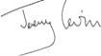

Jeremy Levin

Chairman

Melbourne,
22 February 2021

4

AUDITOR’S INDEPENDENCE DECLARATION
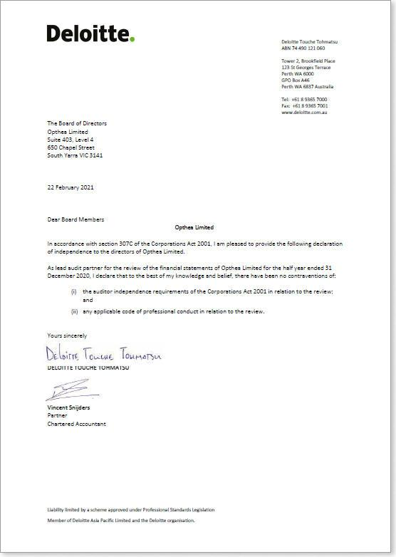

O p t h e a | H A L F Y E A R R E P O R T F O R T H E H A L F - Y E A R E N D E D 3 1 D E C E M B E R 2 0 2 0 | 5
CONDENSED CONSOLIDATED STATEMENT OF PROFIT OR LOSS AND OTHER COMPREHENSIVE INCOME FOR THE HALF-YEAR ENDED 31 DECEMBER 2020

 |  | 31 December
 |  | 2020 | 2019
 | Note | $ | $
Revenue |  | 314,294 | 273,115
Other income |  | 37,500 | –
Research and development expenses |  | (18,807,475) | (8,340,640)
Administrative expenses |  | (5,275,670) | (2,416,266)
Share-based payments expense |  | (2,218,242) | (880,365)
Patent and intellectual property expenses |  | (100,356) | (203,982)
Occupancy expenses |  | (12,247) | (10,442)
Net foreign exchange (loss)/gain | 5 | (12,442,849) | 113,370
Loss before income tax |  | (38,505,045) | (11,465,210)
Income tax benefit | 6 | 3,522,832 | 3,845,192
Loss for period |  | (34,982,213) | (7,620,018)
Other comprehensive income
Items that will not be subsequently reclassified to profit or loss:
Fair value gains on investments in financial assets |  | 649,804 | 83,696
Other comprehensive income for the period |  | 649,804 | 83,696
Total comprehensive loss for the period |  | (34,332,409) | (7,536,322)
Earnings per share for loss attributable for the ordinary equity holders of the parent:
Basic and diluted loss per share (cents) |  | (11.75) | (3.02)

Notes to the financial statements are included on pages 9 to 15.

6

CONDENSED CONSOLIDATED STATEMENT OF FINANCIAL POSITION AS AT 31 DECEMBER 2020

 |  |  | 30 June
 |  | 31 December | 30 June
 |  | 2020 | 2020
 | Note | $ | $
Current Assets
Cash and cash equivalents | 7 | 202,544,985 | 62,020,382
Current tax receivable |  | 3,522,832 | 8,533,123
Receivables |  | 849,940 | 284,391
Prepayments | 8 | 6,083,901 | 478,632
Total current assets |  | 213,001,658 | 71,316,528
Non-current assets
Investments in financial assets | 9 | – | 289,980
Plant and equipment |  | 29,730 | 37,180
Right-of-use asset | 10 | 182,632 | 243,510
Total non-current assets |  | 212,362 | 570,670
Total assets |  | 213,214,020 | 71,887,198
Current liabilities
Payables |  | 2,523,468 | 5,895,034
Lease liabilities | 11 | 145,043 | 145,043
Other financial liabilities | 5 | 12,165,618 | 237,820
Provisions |  | 682,259 | 640,934
Total current liabilities |  | 15,457,279 | 6,918,831
Non-current liabilities
Lease liabilities | 11 | 60,849 | 120,033
Provisions |  | 50,676 | 40,197
Total non-current liabilities |  | 170,709 | 160,230
Total liabilities |  | 15,627,988 | 7,079,061
Net assets |  | 197,586,107 | 64,808,137
Equity
Contributed equity: ordinary shares | 12 | 310,725,758 | 162,102,553
Contributed equity: pre-funded warrants | 12 | 16,268,932 | –
Accumulated losses |  | (137,571,554) | (102,589,341)
Reserves | 13 | 8,162,971 | 5,294,925
Total equity |  | 197,586,107 | 64,808,137

Notes to the financial statements are included on pages 9 to 15.

O p t h e a | H A L F Y E A R R E P O R T F O R T H E H A L F - Y E A R E N D E D 3 1 D E C E M B E R 2 0 2 0 | 7
CONDENSED CONSOLIDATED STATEMENT OF CHANGES IN EQUITY FOR THE HALF-YEAR ENDED 31 DECEMBER 2020

 |  | Share-based | Fair value of
 | Contributed | payments | investments | Accumulated
 | equity | reserve | reserve | losses | Total equity
 | $ | $ | $ | $ | $
As at 1 July 2020 | 162,102,553 | 4,498,830 | 796,095 | (102,589,341) | 64,808,137
Fair value gains on investments in financial assets | – | – | 649,804 | – | 649,804
Loss for the period | – | – | – | (34,982,213) | (34,982,213)
Total comprehensive income and expense for the period | – | – | 649,804 | (34,982,213) | (34,332,409)
Recognition of share based payment | – | 2,218,242 | – | – | 2,218,242
Issue of ordinary shares | 148,623,205 | – | – | – | 148,623,205
Issue of pre-funded warrants | 16,268,932 | – | – | – | 16,268,932
Balance as at 31 December 2020 | 326,994,690 | 6,717,072 | 1,445,899 | (137,571,554) | 197,586,107
As at 1 July 2019 | 113,021,993 | 3,420,348 | 737,255 | (86,060,059) | 31,119,537
Fair value gains on investments in financial assets | – | – | 83,696 | – | 83,696
Loss for the period | – | – | – | (7,620,018) | (7,620,018)
Total comprehensive income and expense for the period | – | – | 83,696 | (7,620,018) | (7,536,322)
Recognition of share based payment | – | 880,365 | – | – | 880,365
Issue of ordinary shares and exercise of LTIP options | 49,142,444 | – | – | – | 49,142,444
Balance as at 31 December 2019 | 162,164,437 | 4,300,713 | 820,951 | (93,680,077) | 73,606,024

Notes to the financial statements are included on pages 9 to 15.

8

CONDENSED CONSOLIDATED STATEMENT OF CASH FLOWS FOR THE HALF-YEAR ENDED 31 DECEMBER 2020

 | 31 December
 | 2020 | 2019
 | $ | $
Cash flows from operating activities
Interest received | 237,547 | 223,521
Royalty and licence income received | 49,320 | 25,412
Grant income received | 37,500 | –
Payment of lease interest | (3,840) | –
Payments to suppliers, employees and for research and development and intellectual property costs (inclusive of GST) | (33,584,098) | (10,975,551)
Research and development tax incentive scheme credit received | 8,533,123 | 14,636,973
Net cash flows (used in)/provided by operating activities | (24,730,448) | 3,910,355
Cash flows from investing activities
Cash received on disposal of financial asset | 939,784 | 482,978
Purchase of plant and equipment | (2,635) | (4,159)
Net cash flows provided by investing activities | 937,149 | 478,819
Cash flows from financing activities
Payment of lease liabilities | (59,184) | (66,664)
Net proceeds on issue of ordinary shares | 148,623,205 | 49,142,444
Net proceeds on issue of pre-funded warrants | 16,268,932 | –
Net cash flows provided by financing activities | 164,832,953 | 49,075,780
Net increase in cash and cash equivalents | 141,039,654 | 53,464,954
Effect of foreign exchange rate changes | (515,051) | 87,778
Cash and cash equivalents at beginning of the period | 62,020,382 | 21,534,919
Cash and cash equivalents at end of the period | 202,544,985 | 75,087,651

Notes to the financial statements are included on pages 9 to 15.

O p t h e a | H A L F Y E A R R E P O R T F O R T H E H A L F - Y E A R E N D E D 3 1 D E C E M B E R 2 0 2 0 9

NOTES TO THE CONDENSED CONSOLIDATED FINANCIAL STATEMENTS FOR THE HALF-YEAR ENDED 31 DECEMBER 2020

1. CORPORATE INFORMATION

The consolidated financial report of Opthea Limited (the Group) for the half-year ended 31 December 2020 was authorised for issue in accordance with a resolution of the directors on 22 February 2021.

Opthea Limited (the parent) is a company limited by shares incorporated in Australia whose ordinary shares are publicly traded on the Australian Securities Exchange (ASX) and whose ADSs are listed on the NASDAQ.

- ADOPTION OF NEW AND REVISED AUSTRALIAN ACCOUNTING STANDARDS

New and amended Accounting Standards that are effective for the current period

The Group has adopted all of the new and revised Standards and Interpretations issued by the Australian Accounting Standards Board (the AASB) that are relevant to their operations and effective for the current half-year.

New and revised Standards and amendments thereof and Interpretations effective for the current half-year that are relevant to the Group include:

- AASB 2018-6 Amendments to Australian Accounting Standards – Definition of a Business

- AASB 2018-7 Amendments to Australian Accounting Standards – Definition of Material

- AASB 2019-1 Amendments to Australian Accounting Standards – References to the Conceptual Framework

- AASB 2019-5 Amendments to Australian Accounting Standards – Disclosure of the Effect of New IFRS Standards Not Yet Issued in Australia

In the current half-year, the Group has applied the above amendments to Australian Accounting Standards issued by the AASB that are effective for the Group’s annual reporting period that began on 1 July 2020. Their adoption has had no material impact on the disclosures and/or amounts reported in these financial statements.

3. SIGNIFICANT ACCOUNTING POLICIES

Basis of preparation

These condensed consolidated financial statements have been prepared on the basis of historical cost, except for the revaluation of certain non-current assets and financial instruments. Cost is based on the fair values of the consideration given in exchange for assets. All amounts are presented in Australian dollars, unless otherwise noted.

The accounting policies and methods of computation adopted in the preparation of the half-year financial report are consistent with those adopted and disclosed in the company’s 2020 annual financial report for the financial year ended 30 June 2020. The accounting policies are consistent with Australian Accounting Standards and with International Financial Reporting Standards.

Research and development costs

Research costs are expensed as incurred. An intangible asset arising from the development expenditure on an internal project will only be recognised when the Group can demonstrate the technical feasibility of completing the intangible asset so that it will be available for use or sale, its intention to complete and its ability to use or sell the asset, how the asset will generate future economic benefits, the availability of resources to complete the development and the ability to measure reliably the expenditure attributable to the intangible asset during its development.

As of 31 December 2020, the Group is in the research phase and has not capitalised any development costs to date.

Income tax

Current tax

Current tax assets and liabilities for the current and prior periods are measured at the amount expected to be recovered from or paid to the taxation authorities based on the current period’s taxable income. The tax rates and tax laws used to compute the amount are those that are enacted or substantively enacted by the reporting date.

Research and development tax incentive

The Research and Development (R&D) Tax Incentive Scheme is an Australian Federal Government program under which eligible companies with annual aggregated revenue of less than $20 million can receive cash amounts equal to 43.5% of eligible research and development expenditures from the Australian Taxation Office (ATO). The R&D Tax Incentive Scheme incentive relates to eligible expenditure incurred in Australia and, under certain circumstances, overseas on the development of the Group’s lead candidate, OPT -302. The R&D tax incentive is applied annually to eligible expenditure incurred during the Group’s financial year following annual application to AusIndustry, an Australian governmental agency, and subsequent filing of its Income Tax Return with the ATO after the financial year end.

10

NOTES TO THE CONSOLIDATED FINANCIAL STATEMENTS FOR THE HALF-YEAR ENDED 31 DECEMBER 2020 (CONT.)

The Group estimates the amount of R&D tax incentive after the completion of the financial year based on eligible Australia and overseas expenditures incurred during that year. The Group has presented incentives in respect of the R&D Tax Incentive Scheme within income tax benefit in the Statement of Profit or Loss and Other Comprehensive Income by analogising with AASB 112 “Income Taxes”.

Leases

The Group assesses at contract inception whether a contract is, or contains, a lease. A contract is, or contains, a lease if the contract conveys the right to control the use of an identified asset for a period of time in exchange for consideration.

The Group applies a single recognition and measurement approach for all leases, except for short-term leases and leases of low-value assets. The Group recognises lease liabilities to make lease payments and right-of-use assets representing the right to use the underlying assets.

Right-of-use assets

Right-of-use assets are recognised at the commencement date of the lease (that is the date the underlying asset is available for use). Right-of-use assets are measured at cost, less any accumulated depreciation and any impairment losses, and adjusted for any remeasurement of lease liabilities. The cost of right-of-use assets includes the amount of lease liabilities recognised, initial direct costs incurred, and lease payments made at or before the commencement date less any lease incentives received. Right-of-use assets are depreciated on a straight-line basis over the shorter of the lease terms and the estimated useful lives of the assets.

Lease liabilities

Lease liabilities are recognised at the commencement date of the lease at the present value of lease payments to be made over the lease term. The lease payments include fixed payments (including in-substance fixed payments) less any lease incentives receivable.

In calculating the present value of lease payments, the Group uses its incremental borrowing rate at the lease commencement date because the interest rate implicit in the lease is not readily determinable. The incremental borrowing rate is determined using market yields on bonds with similar terms to maturity. After the commencement date, the amount of lease liabilities is increased to reflect the accretion of interest and reduced for the lease payments made. In addition, the carrying amount of lease liabilities is remeasured if there is a modification, a change in the lease term, a change in lease payments (e.g. a change to future lease payments resulting from a change in an index or rate).

Leases of low-value assets

For short-term leases (lease term of 12 months or less) and leases of low-value assets (such as photo copiers and telephones), the Group has opted to recognise a lease expense on a straight-line basis as permitted by AASB 16. This expense is presented within “administrative expenses” in the Consolidated Statement of Profit or Loss and Other Comprehensive Income.

Contributed equity – pre-funded warrants

Pre-funded warrants are classified as equity. Incremental costs directly attributable to the issue of new warrants are shown in equity as a deduction, net of tax, from the proceeds.

4. OPERATING SEGMENTS

The Group operates in one industry and one geographical area, those being the biotechnology and healthcare industry and Australia, respectively.

The Group is focused primarily on developing a novel therapy for the treatment of highly prevalent and progressive retinal diseases.

The chief executive officer regularly reviews entity wide information that is compliant with Australian Accounting Standards. There is only one segment for segment reporting purposes, and the information reviewed by the chief executive officer for the purpose of resources allocation and performance assessment is the same as the information presented in the consolidated financial statements.

The Group’s only revenue stream in the current half-year is royalty income generated from licenses granted in respect of the Group’s intellectual property that are unrelated to the Group’s core business and the development of OPT-302 and that are not under development. These licenses are primarily used by third-party licensees for research purposes. All of the royalty income for the half-year ended 31 December 2020 of $41,465 (31 December 2019: $4,390) was generated from customers based outside Australia. The Group does not have any major customers. All property, plant and equipment is located in Australia.

O p t h e a | H A L F Y E A R R E P O R T F O R T H E H A L F - Y E A R E N D E D 3 1 D E C E M B E R 2 0 2 0 | 11

5 . NET FOREIGN EXCHANGE (LOSS)/GAIN

 |  | 31 December
 | 31 December | 31 December
 | 2020 | 2019
 | $ | $
Net foreign exchange (losses)/gains | (277,231) | 87,778
Financial (liabilities)/assets at fair value through profit or loss | (12,165,618) | 25,592
 | (12,442,849) | 113,370

Shortly after the Company’s US IPO where the Company raised USD 128 million, the Company entered into an Australian dollar denominated term deposit worth USD 100 million (AUD 141.9 million), maturing on 3 February 2021. The Company simultaneously entered into a foreign currency exchange contract under which the term deposit will be converted back to US dollars at effectively the same foreign exchange rate as when the term deposit was entered into. The financial liability represents the marked to market value of this foreign currency exchange contract held at 31 December 2020. Subsequent to 31 December 2020, upon maturity and settlement of the term deposit and foreign exchange contract on 3 February 2021, the Australian dollar denominated term deposit was converted back to US dollars for a value of USD 100 million plus interest earned of AUD 116 thousand.

6. INCOME TAX

A reconciliation between tax benefit and the product of accounting loss before income tax multiplied by the Group’s applicable income tax rate is as follows:

 |  | 31 December
 | 31 December | 31 December
 | 2020 | 2019
 | $ | $
Accounting loss before tax | (38,505,045) | (11,465,210)
At the parent entity’s statutory income tax rate of 27.5% | 10,588,887 | 3,152,933
Research and development tax incentive on eligible expenses | 3,522,832 | 3,845,192
Non-deductible R&D expenditure | (2,227,078) | (2,579,092)
Other non-deductible expenses – share based payment expense | (610,017) | (242,100)
Amount of temporary differences and carried forward tax losses not recognised | (7,751,792) | (331,741)
Income tax benefit reported in the Statement of Profit or Loss and Other Comprehensive Income | 3,522,832 | 3,845,192

7. CASH AND CASH EQUIVALENTS

 |  | 30 June
 | 31 December | 30 June
 | 2020 | 2020
 | $ | $
For the purpose of the half-year statement of cash flows, cash and cash equivalents are comprised of the following:
Cash at bank and in hand | 10,603,769 | 3,020,382
Short term deposits | 191,941,216 | 59,000,000
 | 202,544,985 | 62,020,382

Cash at bank earns interest at floating rates based on daily bank deposit rates.

Short term-deposits are with major Australian banks and are made for varying periods of between 90 days and 96 days, depending on the immediate cash requirements of the Group, and earn interest at a fixed rate for the respective short-term deposit periods. At period end, the average rate was 0.36% (2019 half-year: 1.59%).

12

NOTES TO THE CONSOLIDATED FINANCIAL STATEMENTS FOR THE HALF-YEAR ENDED 31 DECEMBER 2020 (CONT.)

8. PREPAYMENTS

 |  |  |  |  | 30 June
 |  |  |  | 31 December | 30 June
 |  |  |  | 2020 | 2020
 |  |  |  | $ | $
Prepayments in respect of insurance premiums paid in advance |  |  |  | 6,074,496 | 466,083
Other administrative expense prepayments |  |  |  | 9,405 | 12,549
 |  |  |  | 6,083,901 | 478,632
9. NON-CURRENT ASSETS – INVESTMENTS IN FINANCIAL ASSETS
 |  |  |  | Fair value
 |  |  |  | gain/(loss)
 | Ownership | Fair value at |  | recognised | Opening fair
 | interest | period end 1 | Disposals | in OCI | value
Listed investments | % | $ | $ | $ | $

31 December 2020

Non-current investments

Antisense Therapeutics Ltd | – | – | – | – | –
Optiscan Imaging Ltd | – | – | (939,784) | 649,804 | 289,980
Total listed investments |  | – | (939,784) | 649,804 | 289,980
30 June 2020
Antisense Therapeutics Ltd | – | – | (482,978) | 249,399 | 233,579
Optiscan Imaging Ltd | 1.73% | 289,980 | – | (190,559) | 480,539
Total listed investments |  | 289,980 | (482,978) | 58,840 | 714,118

- The fair value represents the share (bid) price at period end, and does not include any capital gains tax or selling costs that may be applicable on the disposal of these investments.

Non-current investments in listed shares (which are not associates) are designated and accounted for as investments in financial assets pursuant to AASB 9.

O p t h e a | H A L F Y E A R R E P O R T F O R T H E H A L F - Y E A R E N D E D 3 1 D E C E M B E R 2 0 2 0 | 13

10. RIGHT-OF-USE ASSET

 |  | Lease of
 |  | office
 |  | premises
 |  | $
Right of Use Asset Cost
At 1 July 2020 |  | 365,264
Additions |  | –
At 31 | December 2020 | 365,264
Accumulated depreciation
At 1 July 2020 |  | (121,754)
Charge for the half-year |  | (60,878)
At 31 | December 2020 | (182,632)
Net carrying amount
At 31 | December 2020 | 182,632
At 30 | June 2020 | 243,510

The Group leases its main office accommodation for employees. The term of the lease is three years and is the renewal of a lease for the same premises that expired on 15 July 2019. The lease does not include the option to extend the term of the lease on expiry.

The maturity analysis of lease liabilities is presented in note 11.
 |  | 31 December
 | 31 December | 31 December
 | 2020 | 2019
 | $ | $
Amounts recognised in profit or loss
Depreciation expense on right-of-use asset | 60,878 | 69,197
Lease finance costs | 3,840 | 3,556
Expense relating to leases of low value assets | 4,835 | 4,835
 | 69,553 | 77,588
11. LEASE LIABILITIES
 |  | 30 June
 | 31 December | 30 June
 | 2020 | 2020
 | $ | $
Carrying amount at 1 July | 265,076 | –
New Lease | – | 365,264
Payments | (59,184) | (100,189)
Carrying amount at 31 December/30 June | 205,892 | 265,076
Maturity analysis:
Year 1 | 89,699 | 152,723
Year 2 | 123,873 | 127,713
 | 213,572 | 280,436
Less: unearned interest | (7,680) | (15,360)
 | 205,892 | 265,076
Analysed into:
Current portion | 145,043 | 145,043
Non-current portion | 60,849 | 120,033
 | 205,892 | 265,076

14

NOTES TO THE CONSOLIDATED FINANCIAL STATEMENTS FOR THE HALF-YEAR ENDED 31 DECEMBER 2020 (CONT.)

12. CONTRIBUTED EQUITY

 |  | 30 June
 | 31 December | 30 June
 | 2020 | 2020
 | $ | $
(a) Ordinary shares
Issued and fully paid at 31 December/30 June | 310,725,758 | 162,102,553
Movement in ordinary shares:
Opening balance | 162,102,553 | 113,021,993
Issue of shares in a private placement | – | 48,660,560
Issue of shares on exercise of options granted under the LTIP | – | 420,000
Issue of shares in a US Initial Public Offering (US IPO) and NASDAQ listing | 162,892,597 | –
Cost of issue of shares for US IPO | (14,269,392) | –
 | 310,725,758 | 162,102,553
Ordinary shares on issue: | No: | No:
Opening balance | 269,157,769 | 249,414,839
Issue of shares in a placement | – | 18,867,930
Issue of shares on exercise of options granted under the LTIP | – | 875,000
Issue of shares in a US IPO and NASDAQ listing | 68,506,400 | –
 | 337,664,169 | 269,157,769

Issued capital of ordinary shares at 31 December 2020 amounted to $ 310,725,758 (337,664,169 fully paid ordinary shares) net of share issue costs and tax. During the half-year, the Company issued 68,506,400 ordinary shares for $148,623,205 net of issue costs in respect of a US initial public offering of American Depositary Shares (ADSs) on the NASDAQ.

 |  | 30 June
 | 31 December | 30 June
 | 2020 | 2020
 | $ | $
(b) Pre-funded warrants
Movement in pre-funded warrants:
Opening balance | – | –
Issue of pre-funded warrants in a US IPO | 17,818,059 | –
Cost of issue of pre-funded warrants | (1,549,127)
 | 16,268,932 | –
Pre-funded warrants on issue: | No: | No:
Opening balance | – | –
Issue of pre-funded warrants in a US IPO | 7,493,600 | –
 | 7,493,600 | –

The Company issued 7,493,600 pre-funded warrants for $16,268,932 net of issue costs in respect of a US initial public offering.
The pre-funded warrants are unquoted, have no voting or dividend rights attached and are exercisable to ADSs at an exercise price of US$0.00001 per pre-funded warrant on a one for one basis with no expiry date.

O p t h e a | H A L F Y E A R R E P O R T F O R T H E H A L F - Y E A R E N D E D 3 1 D E C E M B E R 2 0 2 0 | 15

13. RESERVES

 |  | 30 June
 | 31 December | 30 June
 | 2020 | 2020
 | $ | $
Fair value of investments reserve 1 | 1,445,899 | 796,095
Share-based payments reserve 2 | 6,717,072 | 4,498,830
Total reserves | 8,162,971 | 5,294,925
1. Movement in fair value of investments reserve:
Opening balance | 796,095 | 737,255
Fair value gains on investments in financial assets | 649,804 | 58,840
Closing balance | 1,445,899 | 796,095
2. Movement in share-based payments reserve:
Opening balance | 4,498,830 | 3,420,349
Share-based payments expense | 2,218,242 | 1,078,481
Closing balance | 6,717,072 | 4,498,830

- COMMITMENTS

The Company has entered into research and development contracts with various third parties in respect of the manufacture of clinical grade OPT-302 and services for the Phase 3 wet AMD clinical trials. Expenditure commitments relating to these and intellectual property license agreements are payable as follows:

 |  | 30 June
 | 31 December | 30 June
 | 2020 | 2020
 | $ | $
Within one year | 18,573,692 | 11,145,736
After one year but not more than five years | 1,066,071 | 444,143
After more than five years | 97,298 | 109,061
 | 19,737,061 | 11,698,940

- EVENTS SUBSEQUENT TO REPORTING DATE

No matters or circumstances have arisen since the end of the reporting period, not otherwise disclosed in this report, which significantly affected, or may significantly affect, the operations of the Group, the results of those operations, or the state of affairs of the Group in future financial years.

16

DIRECTORS’ DECLARATION

The Directors declare that:

- in the Directors’ opinion, there are reasonable grounds to believe that the company will be able to pay its debts as and when they become due and payable; and

- in the Directors’ opinion, the attached financial statements and notes thereto are in accordance with the Corporations Act 2001, including compliance with accounting standards and giving a true and fair view of the financial position and performance of the consolidated entity.

Signed in accordance with a resolution of the Directors made pursuant to s.303(5) of the Corporations Act 2001.

On behalf of the Directors
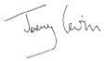

Jeremy Levin
Chairman

Melbourne,
22 February 2021

O p t h e a | H A L F Y E A R R E P O R T F O R T H E H A L F - Y E A R E N D E D 3 1 D E C E M B E R 2 0 2 0 17

INDEPENDENT AUDITOR’S REVIEW REPORT


Deloitte Touche Tohmatsu

ABN 74 490 121 060

Tower 2, Brookfield Place

123 St Georges Terrace

Perth WA 6000

GPO Box A46

Perth WA 6837 Australia

Tel: +61 8 9365 7000

Fax: +61 8 9365 7001

www.deloitte.com.au

Independent Auditor’s Review Report to the members of Opthea Limited

Conclusion

We have reviewed the half-year financial report of Opthea Limited (the “Company”) and its subsidiary (the “Group”), which comprises the condensed consolidated statement of financial position as at 31 December 2020, and the condensed consolidated income statement, the condensed consolidated statement of comprehensive income, the condensed consolidated statement of cash flows and the condensed consolidated statement of changes in equity for the half-year ended on that date, notes comprising a summary of significant accounting policies and other explanatory information, and the directors’ declaration as set out on pages 5 to 16.

Based on our review, which is not an audit, we have not become aware of any matter that makes us believe that the half-year financial report of
Opthea Limited is not in accordance with the Corporations Act 2001, including:

- giving a true and fair view of the Group’s financial position as at 31 December 2020 and of its performance for the half-year ended on that date; and

- complying with Accounting Standard AASB 134 Interim Financial Reporting and the Corporations Regulations 2001.

Basis for Conclusion

We conducted our review in accordance with ASRE 2410 Review of a Financial Report Performed by the Independent Auditor of the Entity. Our responsibilities are further described in the Auditor’s Responsibilities for the Review of the Half-year Financial Report section of our report. We are independent of Opthea Limited in accordance with the ethical requirements of the Accounting Professional and Ethical Standards Board’s APES 110 Code of Ethics for Professional Accountants (including Independence Standards) (the Code) that are relevant to our audit of the annual financial report in Australia. We have also fulfilled our other ethical responsibilities in accordance with the Code.

We confirm that the independence declaration required by the Corporations Act 2001, which has been given to the directors of the Company, would be in the same terms if given to the directors as at the time of this auditor’s review report.

Directors’ Responsibilities for the Half-year Financial Report

The directors of the Company are responsible for the preparation of the half-year financial report that gives a true and fair view in accordance with Australian Accounting Standards and the Corporations Act 2001 and for such internal control as the directors determine is necessary to enable the preparation of the half-year financial report that gives a true and fair view and is free from material misstatement, whether due to fraud or error.

Liability limited by a scheme approved under Professional Standards Legislation

Member of Deloitte Asia Pacific Limited and the Deloitte organisation.

18

INDEPENDENT AUDITOR’S REVIEW REPORT (CONT.)


Auditor’s Responsibilities for the Review of the Half-year Financial Report

Our responsibility is to express a conclusion on the half-year financial report based on our review. ASRE 2410 requires us to conclude whether we have become aware of any matter that makes us believe that the half-year financial report is not in accordance with the Corporations Act 2001 including giving a true and fair view of the Group’s financial position as at 31 December 2020 and its performance for the half-year ended on that date, and complying with Accounting Standard AASB 134 Interim Financial Reporting and the Corporations Regulations 2001.

A review of a half-year financial report consists of making enquiries, primarily of persons responsible for financial and accounting matters, and applying analytical and other review procedures. A review is substantially less in scope than an audit conducted in accordance with Australian Auditing Standards and consequently does not enable us to obtain assurance that we would become aware of all significant matters that might be identified in an audit. Accordingly, we do not express an audit opinion.

DELOITTE TOUCHE TOHMATSU

Vincent Snijders
Partner
Chartered Accountants
Perth, 22 February 2021



