UNITED STATES

SECURITIES AND EXCHANGE COMMISSION
WASHINGTON, D.C. 20549

FORM 6-K

REPORT OF FOREIGN PRIVATE ISSUER PURSUANT TO RULE 13a-16 OR 15d-16 UNDER THE SECURITIES EXCHANGE ACT OF 1934

For the Month of August 2021

Commission File Number: 001-39621

OPTHEA LIMITED

(Translation of registrant’s name into English)

Level 4

650 Chapel Street

South Yarra, Victoria 3141

Australia

(Address of principal executive offices)

Indicate by check mark whether the registrant files or will file annual reports under cover of Form 20-F or Form 40-F.

Form 20-F ☒ Form 40-F ☐

Indicate by check mark if the registrant is submitting the Form 6-K in paper as permitted by Regulation S-T Rule 101(b)(1): ☐

Indicate by check mark if the registrant is submitting the Form 6-K in paper as permitted by Regulation S-T Rule 101(b)(7): ☐

EXHIBITS

Exhibit Description

99.1 Press Release dated August 30, 2021

99.2 Opthea Appendix 4E and Annual Report

99.3 Opthea Appendix 4G Corporate Governance Statement 2021

SIGNATURES

Pursuant to the requirements of the Securities Exchange Act of 1934, the registrant has duly caused this report to be signed on its behalf by the undersigned, thereunto duly authorized.

OPTHEA LIMITED

Date: August 30, 2021 By: /s/ Megan Baldwin

Megan Baldwin, Ph.D.

Chief Executive Officer and Managing Director

Exhibit 99.1


Opthea Reports Fiscal Year 2021 Financial Results and Corporate Highlights

Treated First Patient in Phase 3 Pivotal Trials of OPT-302 in Wet Age-Related Macular Degeneration (AMD)

OPT-302 Granted FDA Fast Track Designation for Wet AMD

Received FDA Waiver for Pediatric Study Plan for OPT-302 in Wet AMD

ShORe and COAST Phase 3 Clinical Trials Opened Recruitment to Patients in U.S. & Canada

Melbourne, Australia; August 30, 2021 – Opthea Limited (ASX:OPT; Nasdaq:OPT), a clinical stage biopharmaceutical company developing novel therapies to treat highly prevalent and progressive retinal diseases, today reported financial results for the year ended June 30, 2021 and provided an overview of recent progress and accomplishments.

“Despite the continued impact of COVID-19 around the world, our team has continued to make steady progress advancing our lead program, OPT-302, and strengthening the Company for continued global expansion,” said Dr. Megan Baldwin, CEO and Managing Director of Opthea. “Dosing the first patients in our OPT-302 Phase 3 pivotal clinical program in wet AMD marked a very important achievement for Opthea in accelerating the development of this novel VEGF-C/D inhibitor therapy towards market registration. FDA Fast Track designation for OPT-302 also provides regulatory support in expediting the Phase 3 development program to advance our promising treatment to patients sooner. These encouraging developments bring us closer to accomplishing our mission to improve the lives of patients suffering from retinal diseases.”

Corporate Highlights

- In March 2021, Opthea announced that the first patient had been treated in its Phase 3 pivotal program for OPT-302 for wet AMD. Opthea is conducting two concurrent global, multi-center, randomized, double-masked, sham-controlled Phase 3 trials known as ShORe and COAST.

- In March 2021, Opthea announced that it received an initial Pediatric Study Plan (iPSP) waiver from the U.S. Food and Drug Administration (FDA) for OPT-302. With this waiver, Opthea will not have to conduct an additional study of OPT-302 in the pediatric population for use of OPT-302 in this U.S. population.

- In July 2021, the FDA granted Fast Track designation for OPT-302 in combination with anti-VEGF- A therapy for the treatment of patients with wet AMD. Fast Track designation offers benefits to expedite the OPT-302 Phase 3 clinical program and subsequent potential approval process.

- In August 2021, Opthea announced the expansion of the Phase 3 ShORe and COAST wet AMD trials of OPT-302 into Canada. With the Phase 3 pivotal clinical program ongoing in the U.S., the expansion into Canada represents a new and important geographical region.

- Over the past year, Opthea strengthened its Board of Directors with the appointment of Dr. Jeremy Levin as Chairman and Dr. Julia Haller and Ms. Judith Robertson as non-executive directors.

Fiscal Year 2021 Financial Results

As of June 30, 2021, Opthea had cash, cash equivalents and short-term investments of US$118.2 million.

Research and development expenses for the fiscal year ended June 30, 2021 were US$25.9 million, compared to US$12.1 million for the year ended June 30, 2020. The increase of US$13.8 million reflects costs associated with the Phase 2b and Phase1b/2a clinical trials of OPT-302 for wet AMD and DME and the initiation of the Phase 3 clinical trials. Administrative expenses for the fiscal year ended June 30, 2021 were US$13.4 million, compared to US$4.7 million for the same prior year period.

Opthea reported a net loss, including non-cash charges, of US$45.3 million or $0.14 per share for the year ended June 30, 2021. This compares to a net loss, including non-cash charges, of US$11.1 or $0.04 per share for the comparable period in 2020.

A copy of Opthea’s financial results and Annual Report for the financial year ending June 30, 2021 is available on the Company’s website www.opthea.com/annual-reports/.

About Opthea Limited

Opthea (ASX:OPT; Nasdaq:OPT) is a biopharmaceutical company developing novel therapies to address the unmet need in the treatment of highly prevalent and progressive retinal diseases, including wet age-related macular degeneration (wet AMD) and diabetic macular edema (DME). Opthea’s lead product candidate OPT-302 is in pivotal Phase 3 clinical trials and being developed for use in combination with anti-VEGF-A monotherapies to achieve broader inhibition of the VEGF family, with the goal of improving overall efficacy and demonstrating superior vision gains over that which can be achieved by inhibiting VEGF-A alone.

Inherent risks of Investment in Biotechnology Companies

There are a number of inherent risks associated with the development of pharmaceutical products to a marketable stage. The lengthy clinical trial process is designed to assess the safety and efficacy of a drug prior to commercialization and a significant proportion of drugs fail one or both of these criteria. Other risks include uncertainty of patent protection and proprietary rights, whether patent applications and issued patents will offer adequate protection to enable product development, the obtaining of necessary drug regulatory authority approvals and difficulties caused by the rapid advancements in technology. Companies such as Opthea are dependent on the success of their research and development projects and on the ability to attract funding to support these activities. Investment in research and development projects cannot be assessed on the same fundamentals as trading and manufacturing enterprises. Therefore, investment in companies specializing in drug development must be regarded as highly speculative. Opthea strongly recommends that professional investment advice be sought prior to such investments.

Forward-Looking Statements

Certain statements in this announcement may contain forward-looking statements, including within the meaning of the U.S. Private Securities Litigation Reform Act of 1995. Any statement describing Company goals, expectations, intentions or beliefs is a forward-looking statement and should be considered an at risk statement, including, but not limited to, the continuation of Opthea’s pivotal Phase 3 clinical trials of OPT-302 in wet AMD. Such statements are based on Opthea’s current plans, objectives, estimates, expectations and intentions and are subject to certain risks and uncertainties, including risks and uncertainties associated with clinical trials and product development and the impact of general economic, industry or political conditions in Australia, the United States or internationally. These and other risks and uncertainties are described more fully in Opthea’s filings with the ASX and the U.S. Securities and Exchange Commission, including in the section titled “Risk Factors” in the final prospectus filed with the SEC on October 19, 2020. The Company undertakes no obligation to publicly update any forward-looking statement, whether as a result of new information, future events, or otherwise, except as required under applicable law. You should not place undue reliance on these forward-looking statements as predictions of future events, which statements apply only as of the date of this announcement. Actual results could differ materially from those discussed in this ASX announcement.

Authorized for release to ASX by Megan Baldwin, CEO & Managing Director.

Company & Media Enquiries:

Australia: |  |  |  |  |  | U.S.A. & International:
Rudi Michelson, Monsoon Communications |  |  |  |  |  | Sam Martin, Argot Partners
Tel: +61 (0) | 3 9620 3333 |  |  |  |  | Tel: +1 212-600-1902; opthea@argotpartners.com
Join our email database to receive program updates:
Tel: +61 (0) | 3 9826 0399 Email: info@opthea.com Web: www.opthea.com

Exhibit 99.2
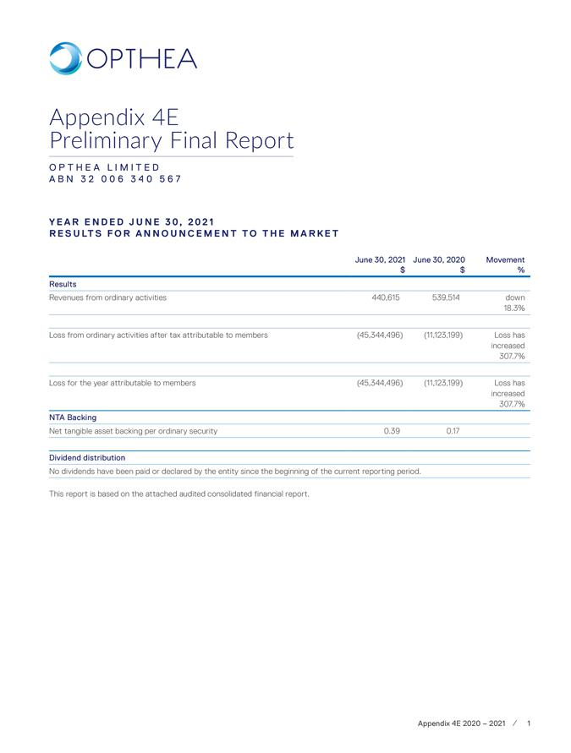



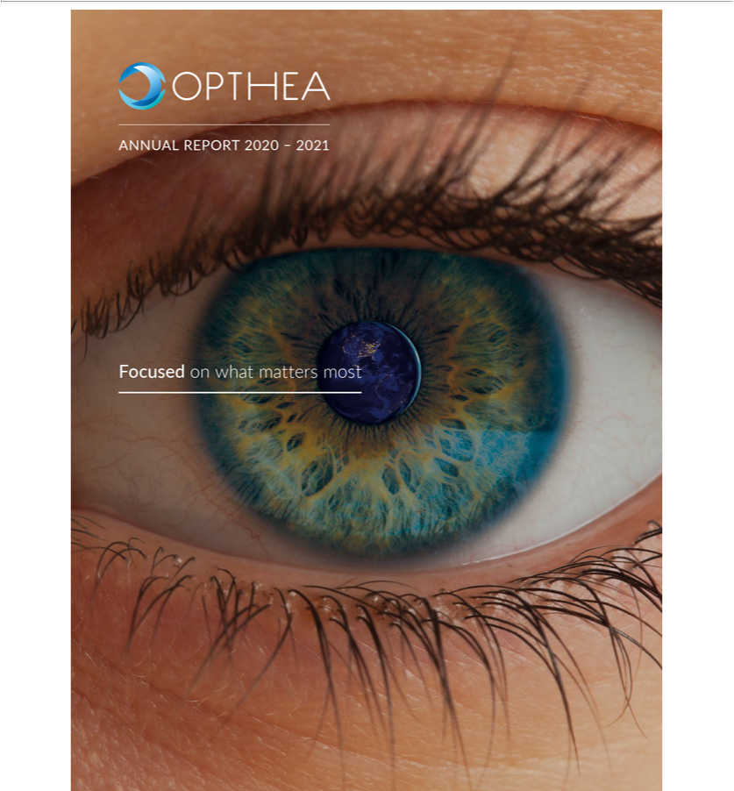





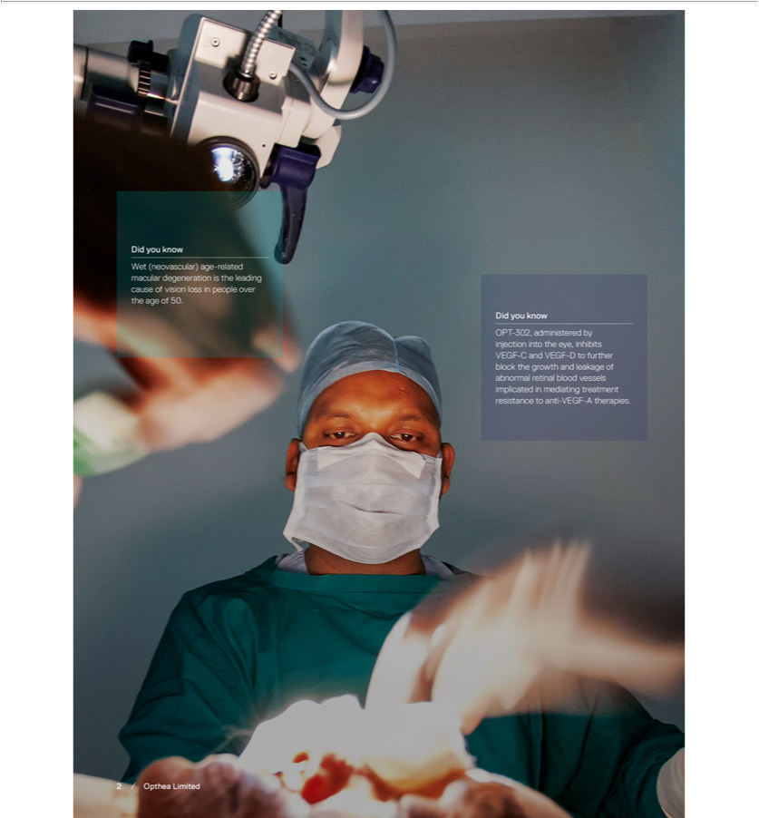

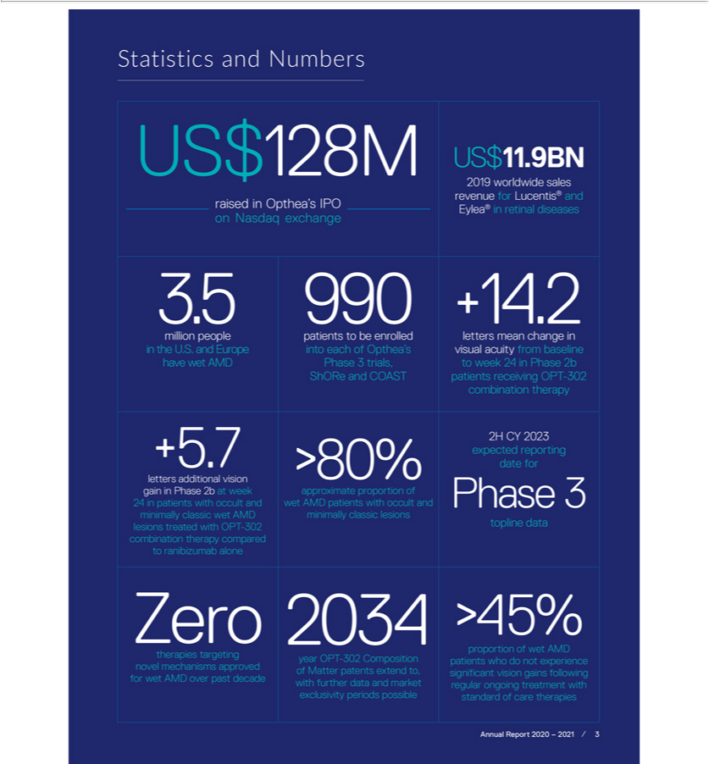



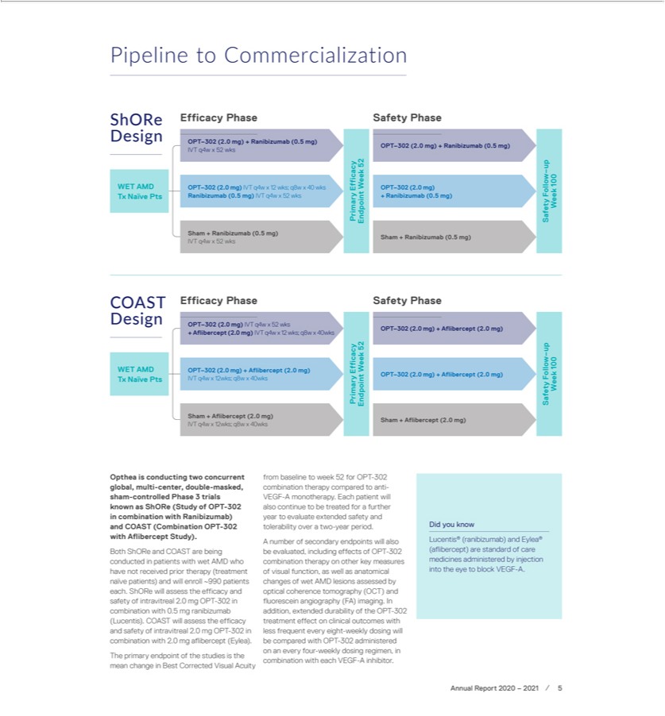

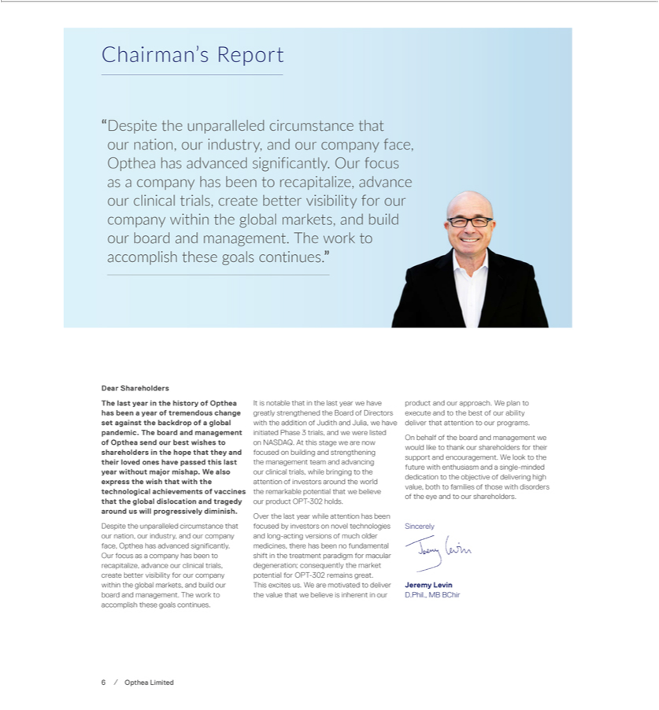

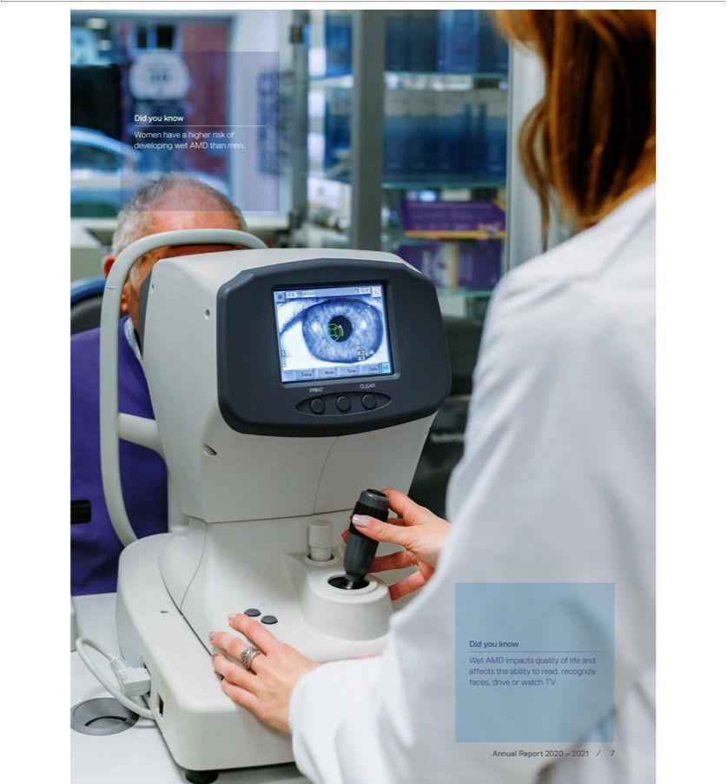

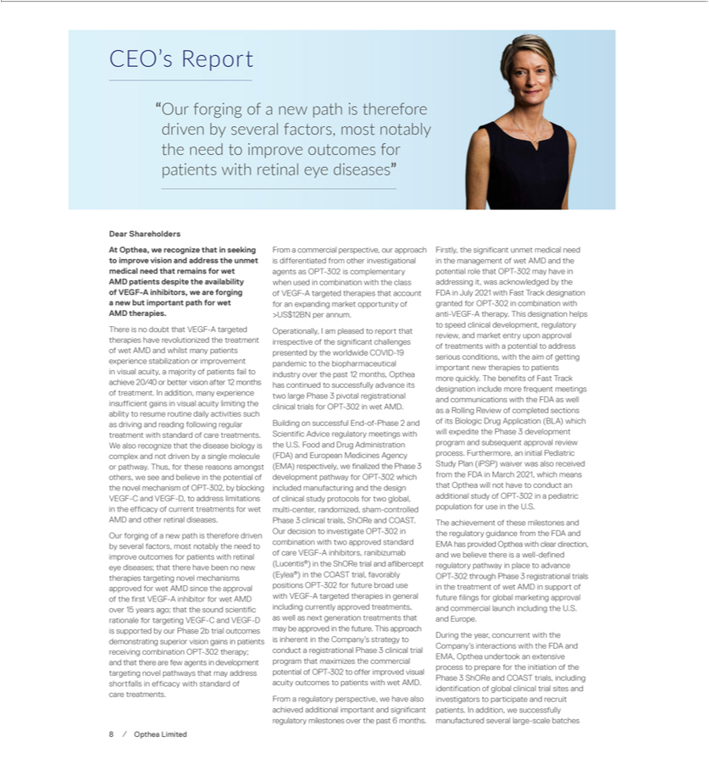

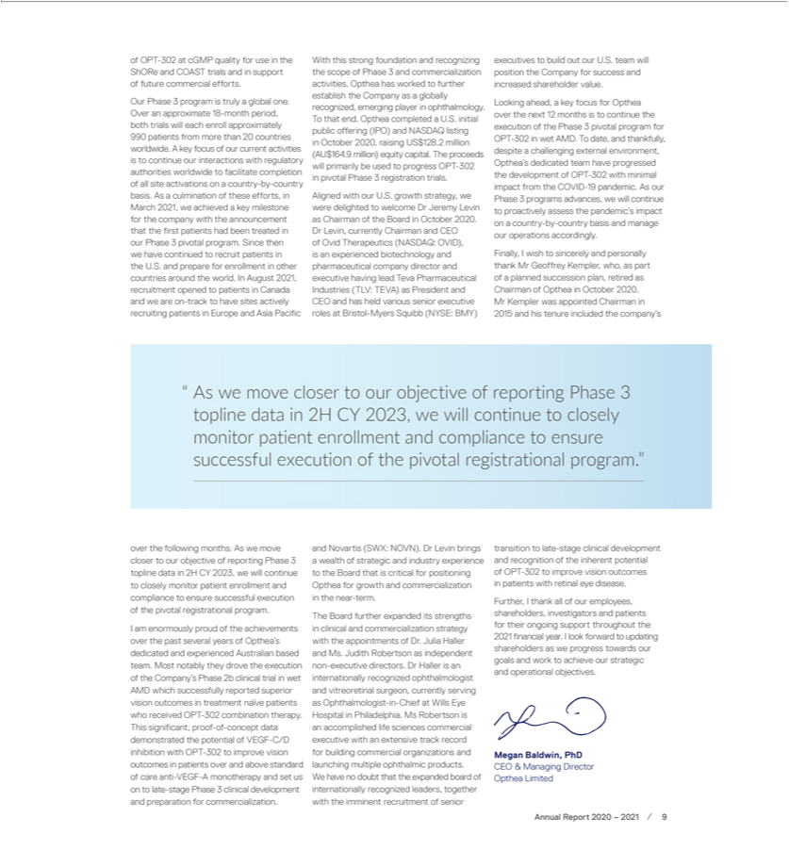

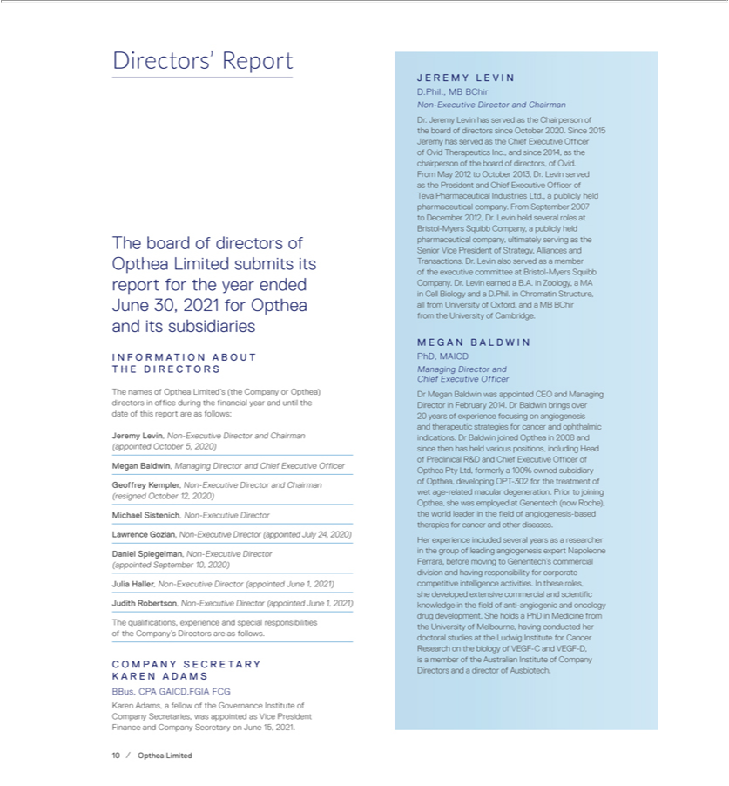

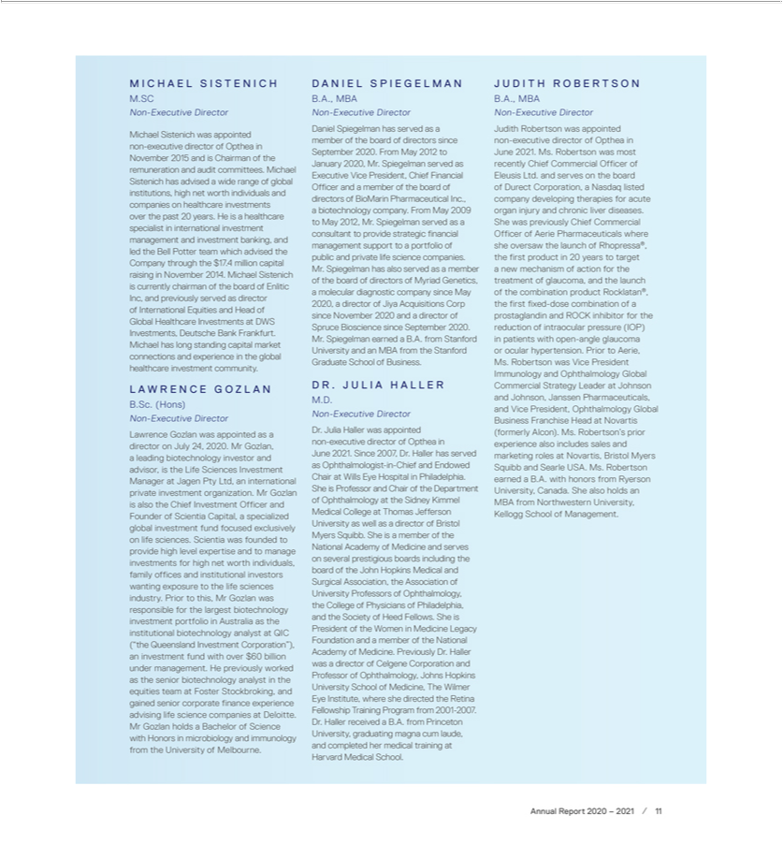

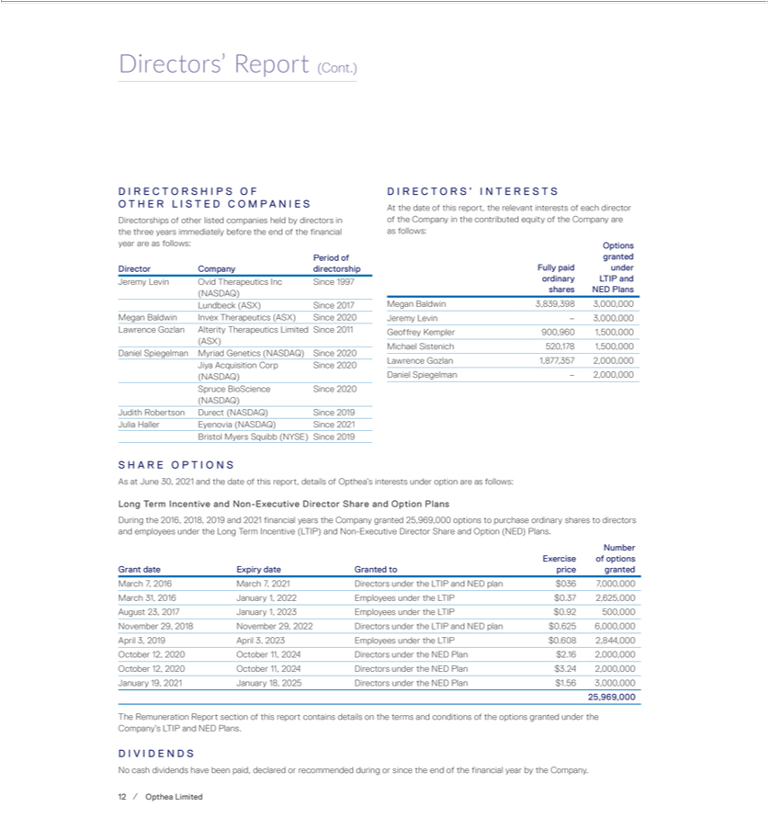

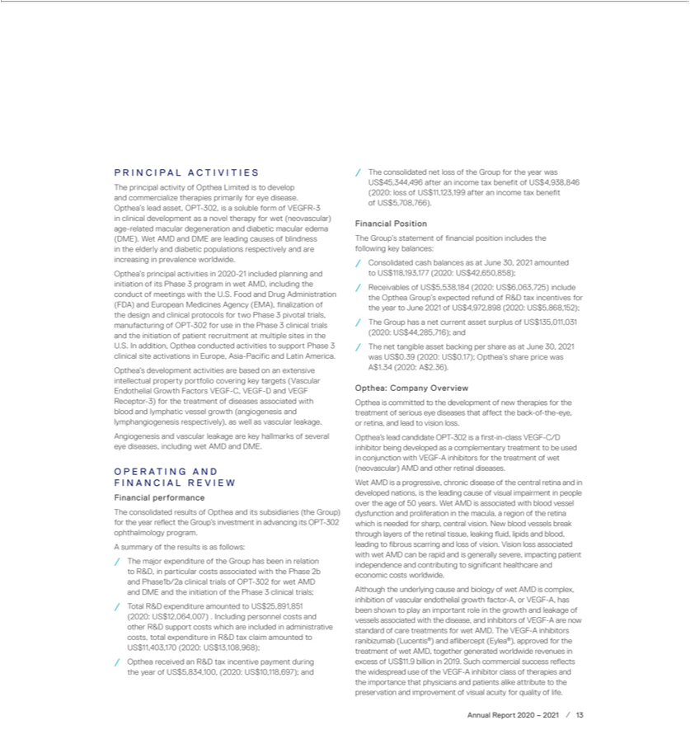

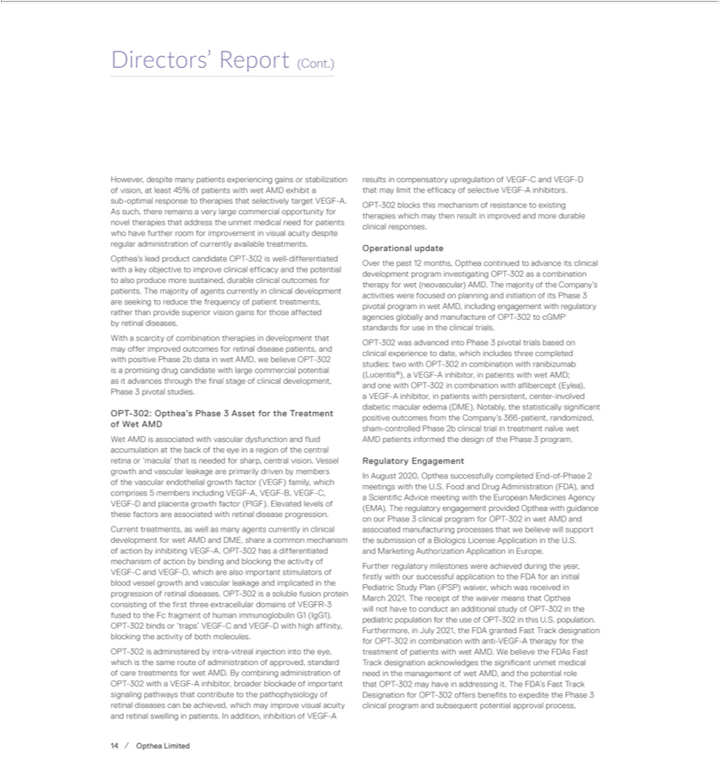

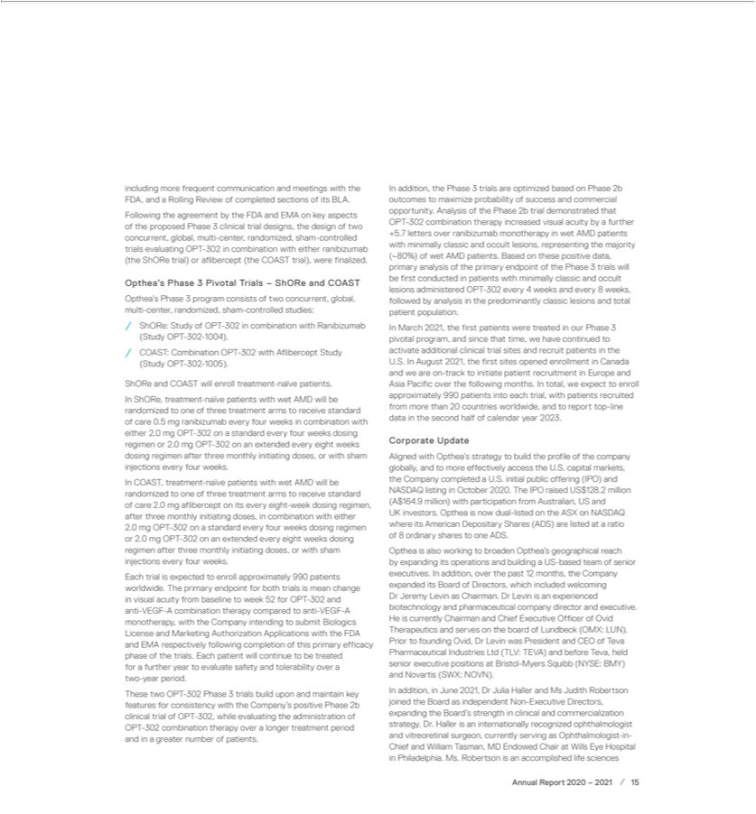

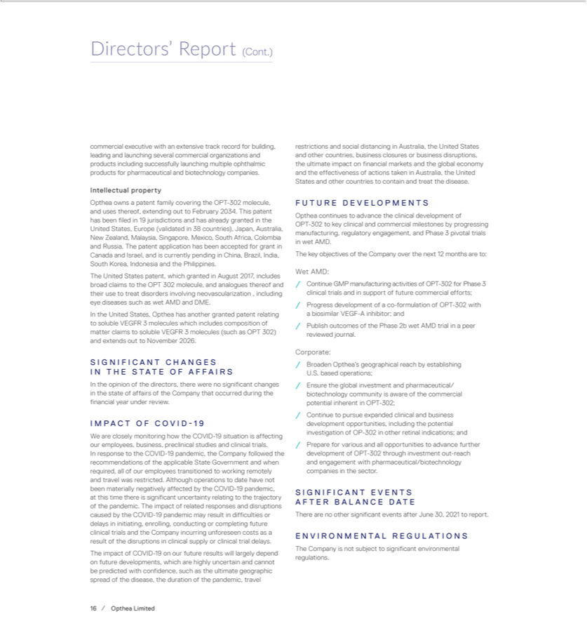

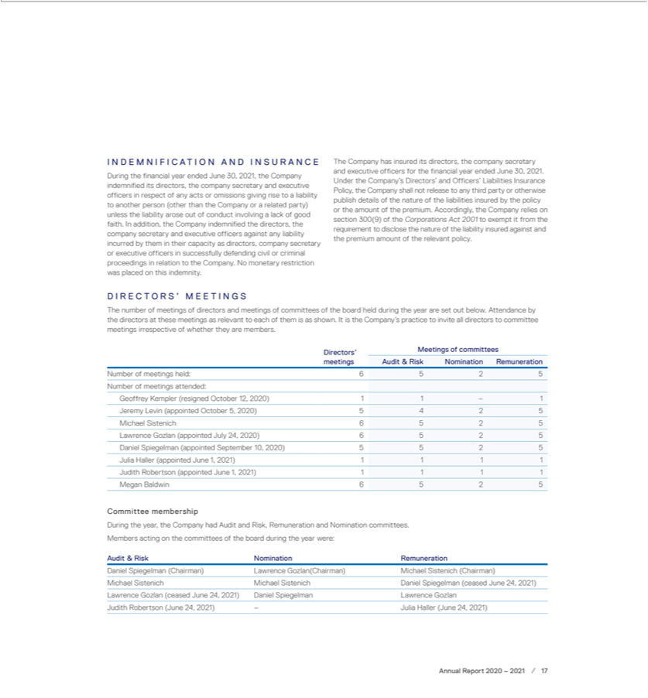

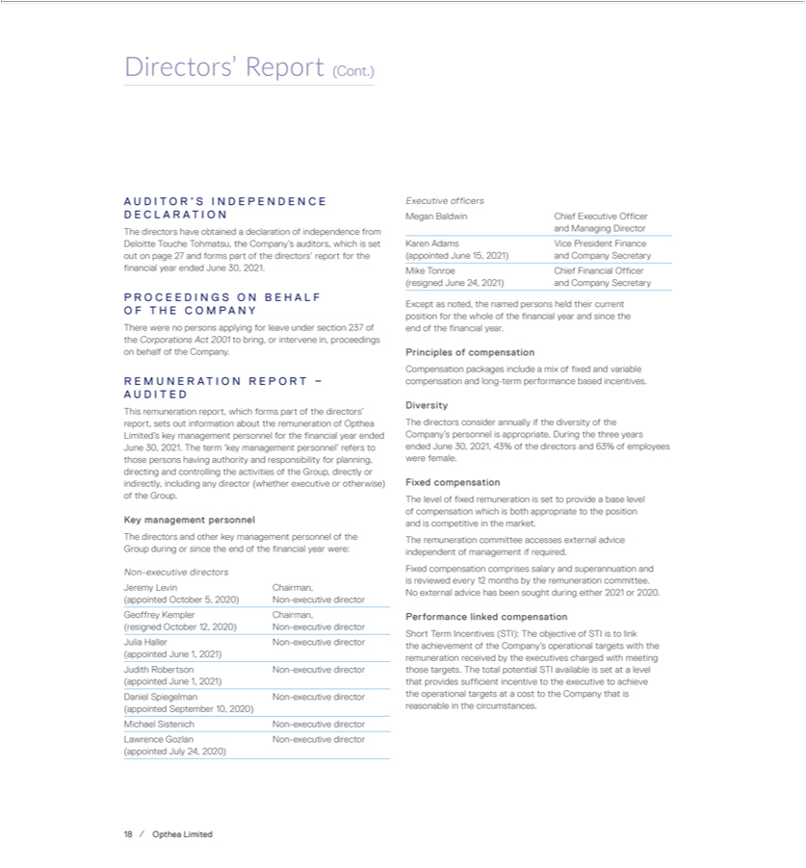

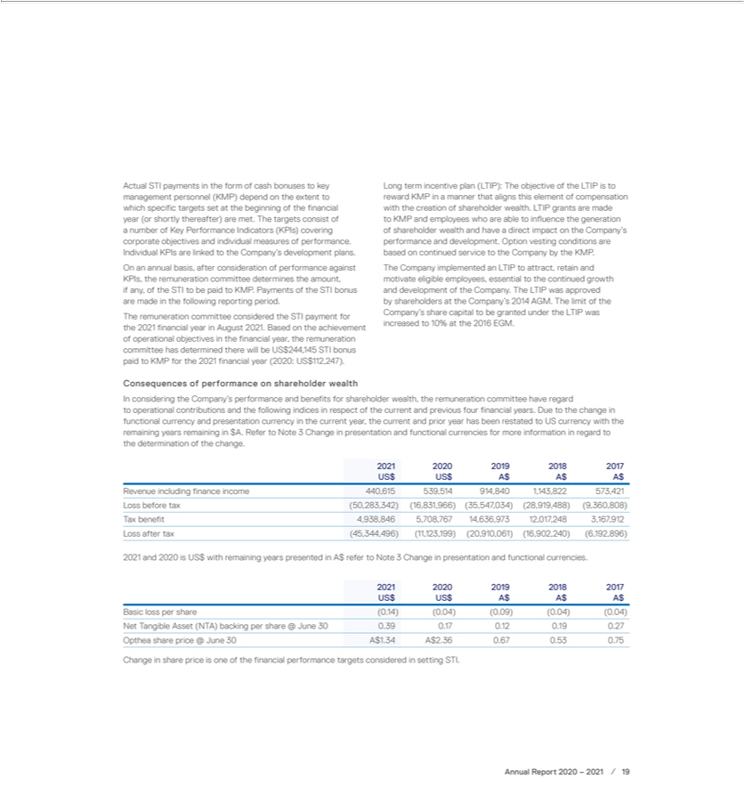

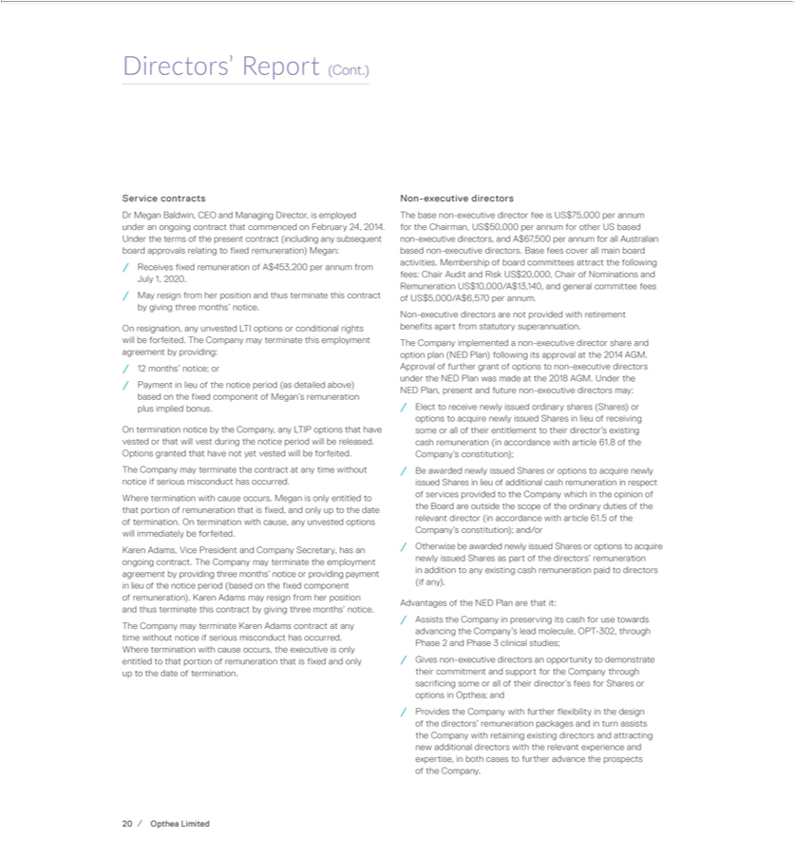

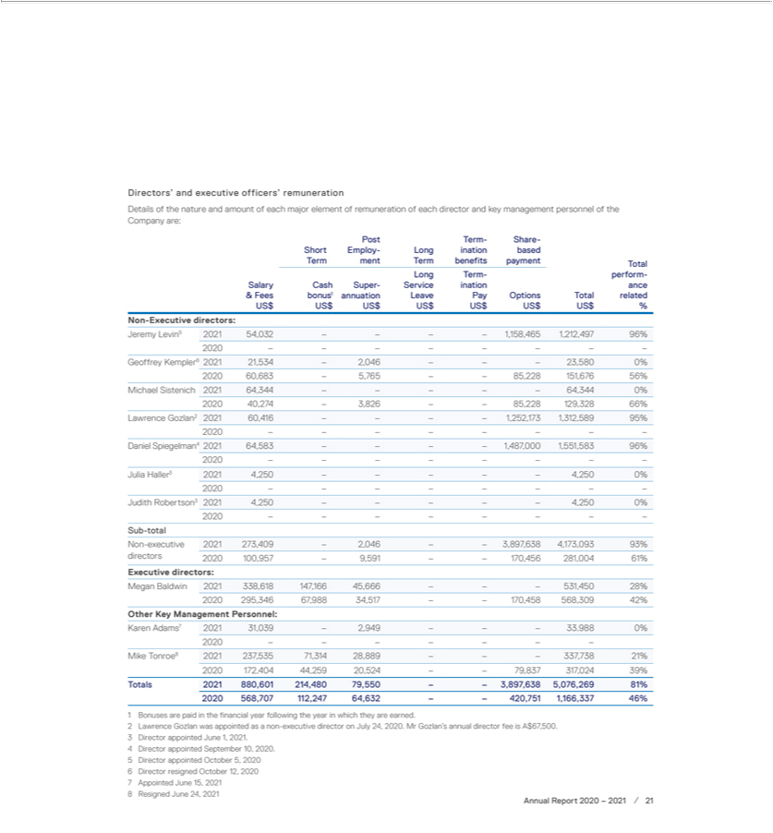

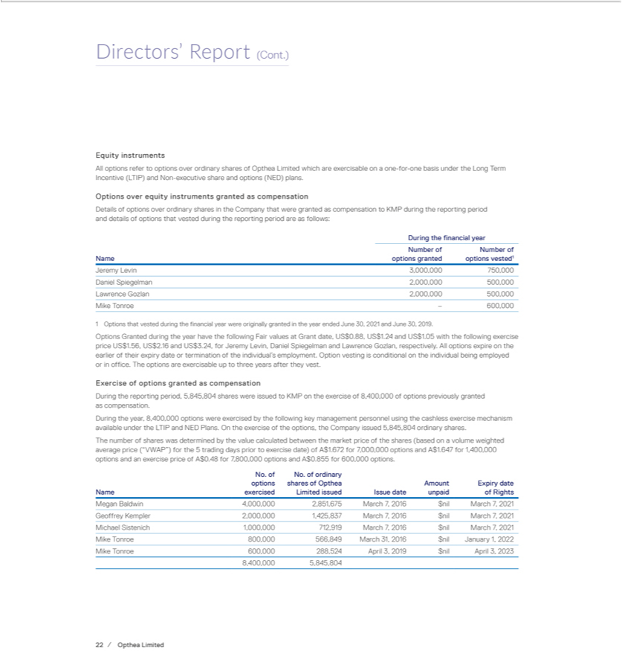

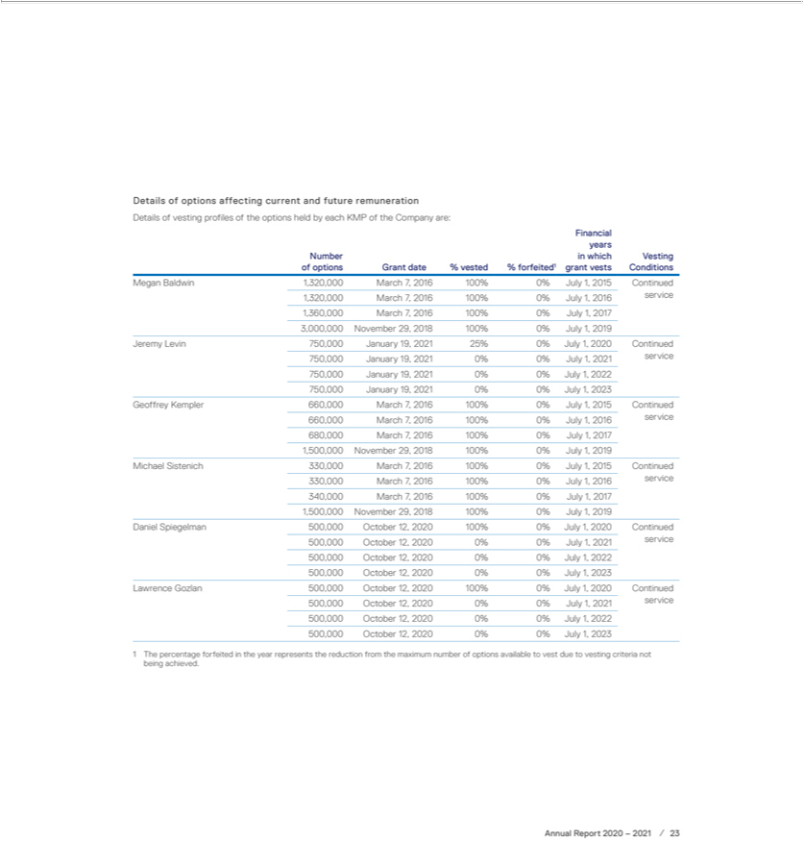

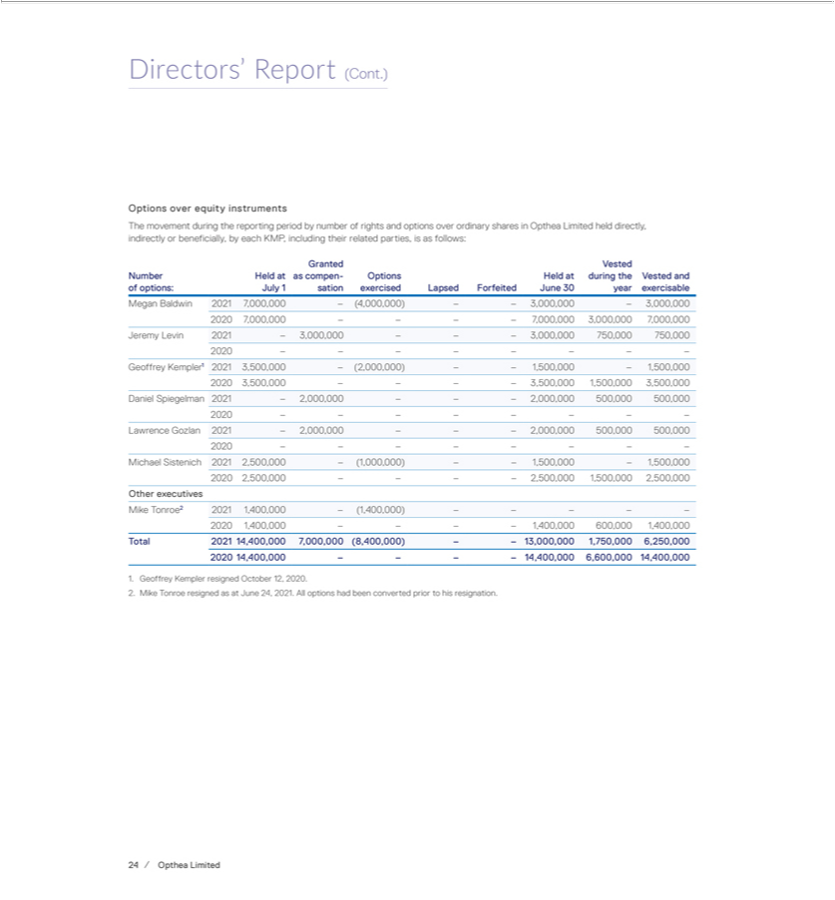

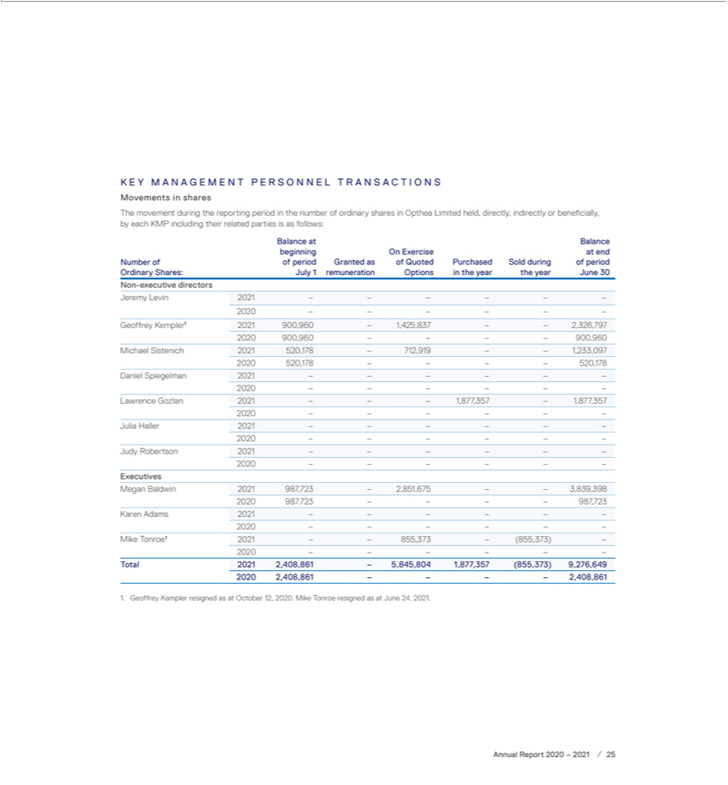

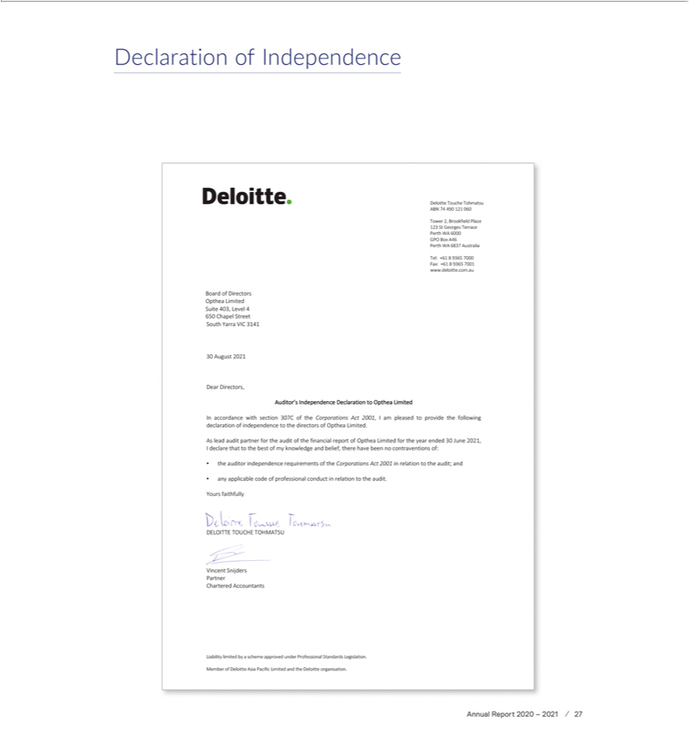











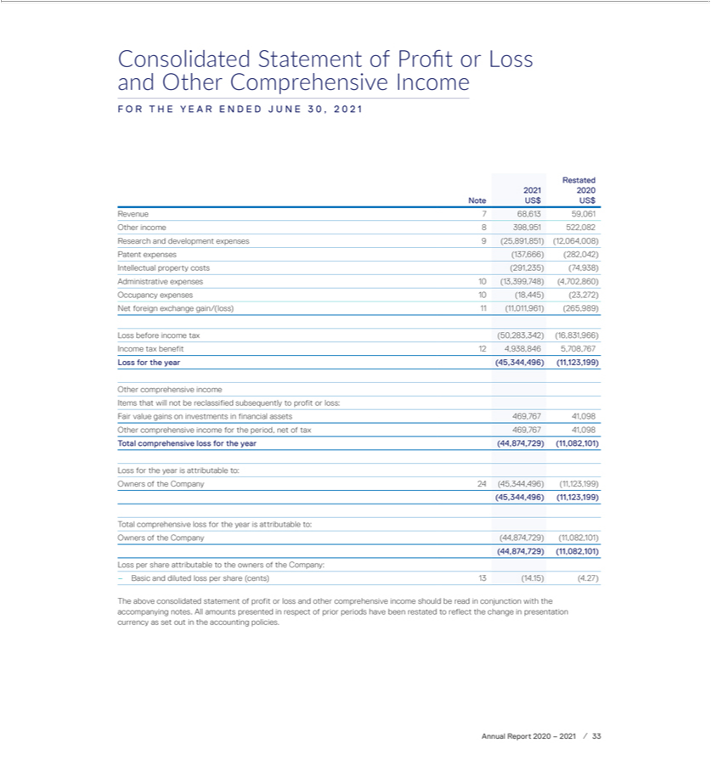

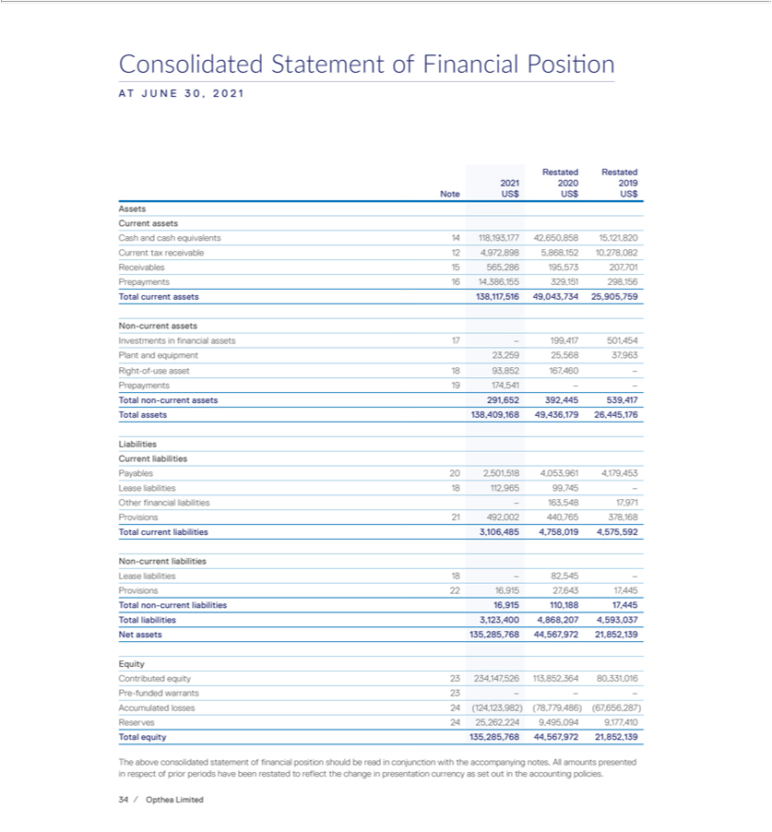

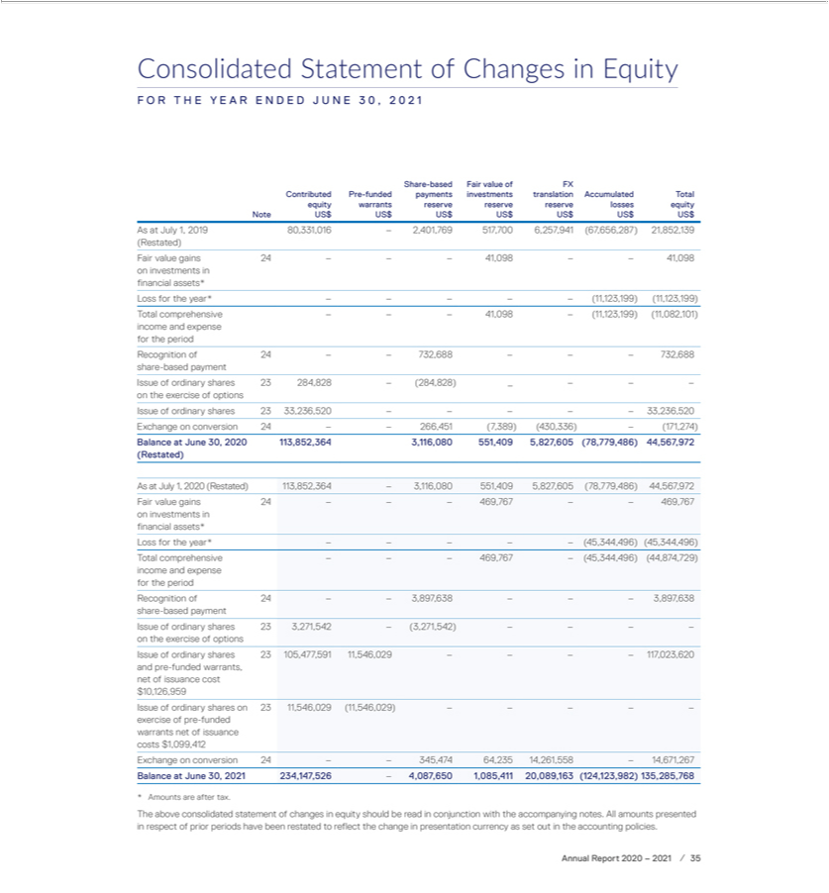

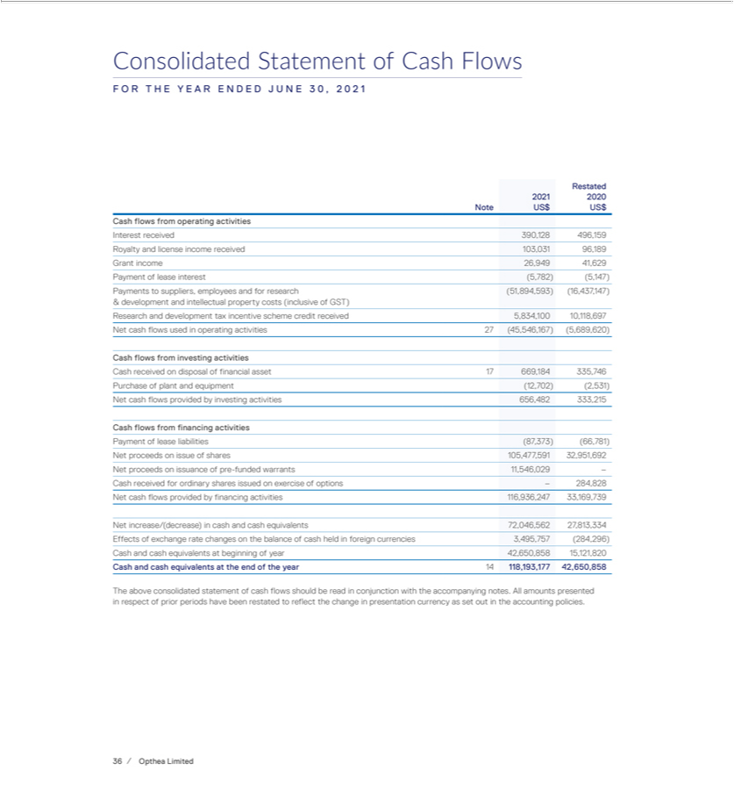





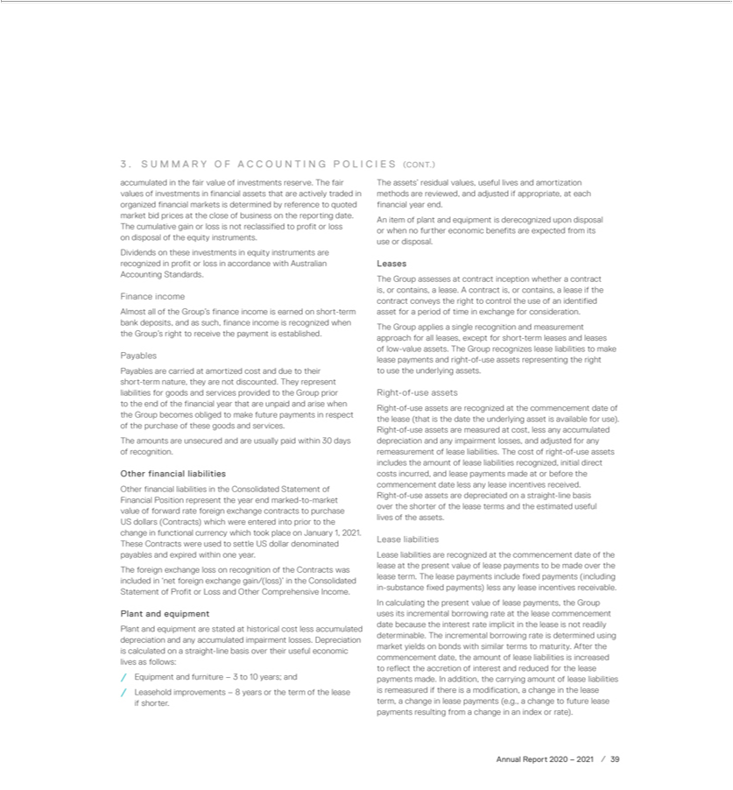



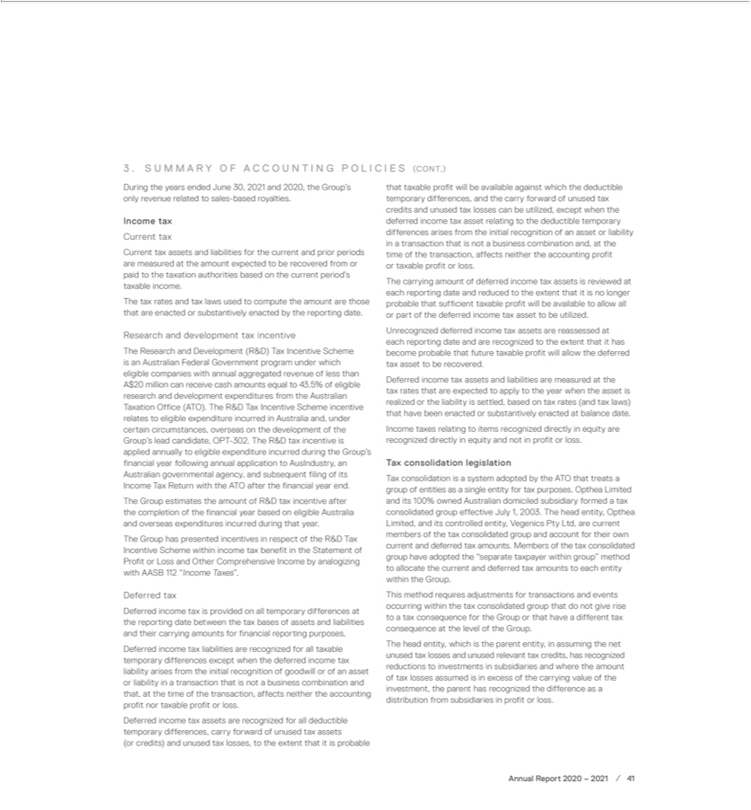



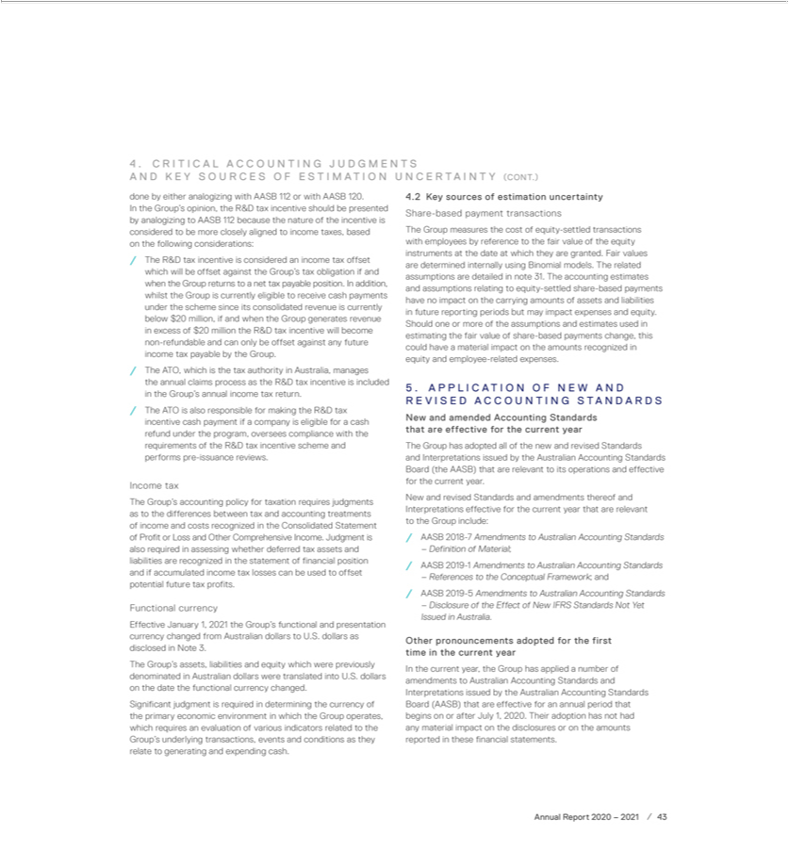



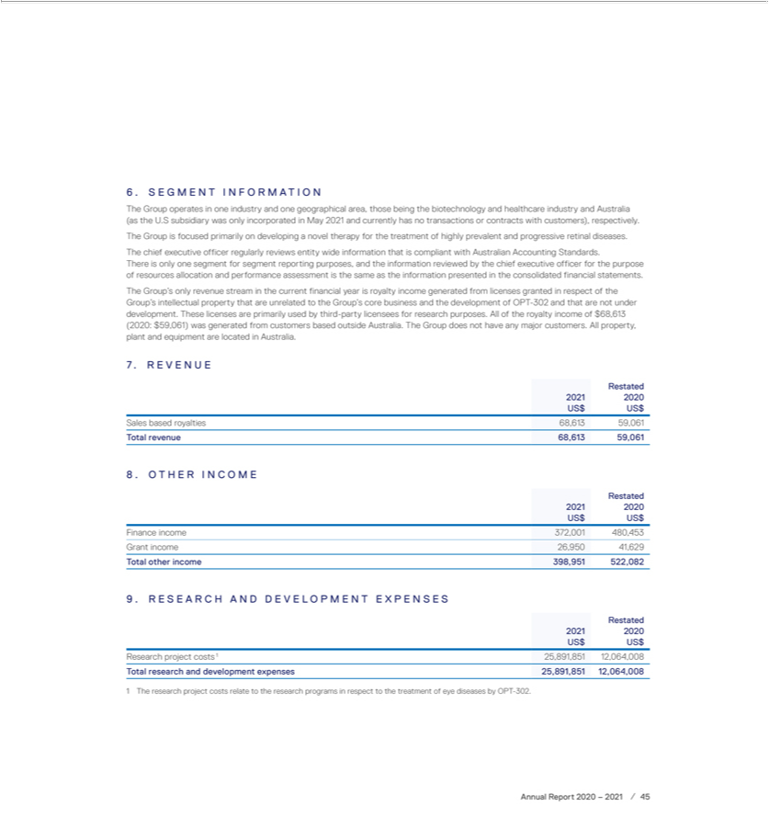

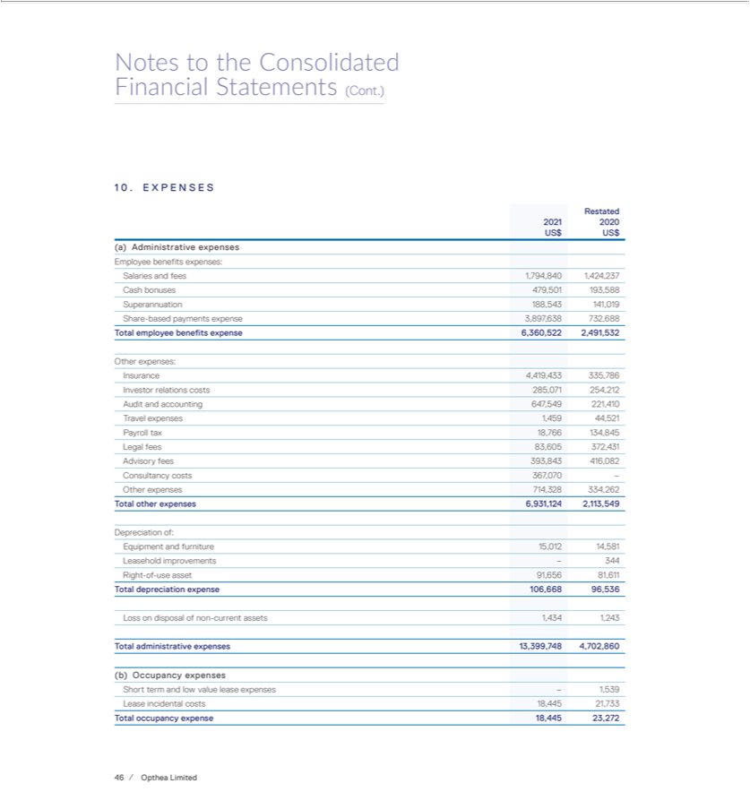

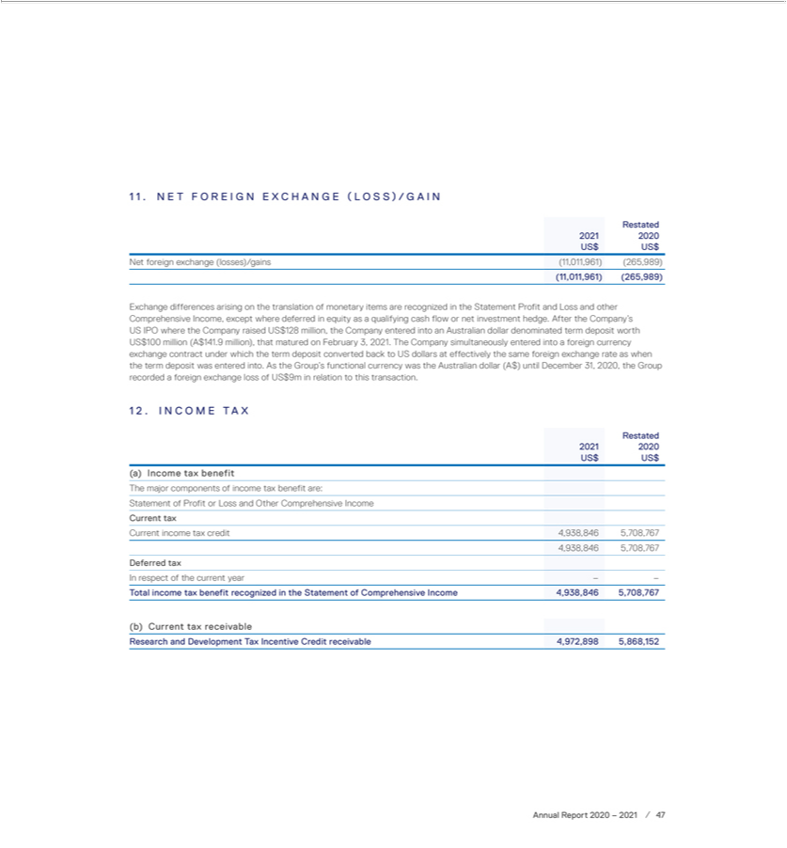



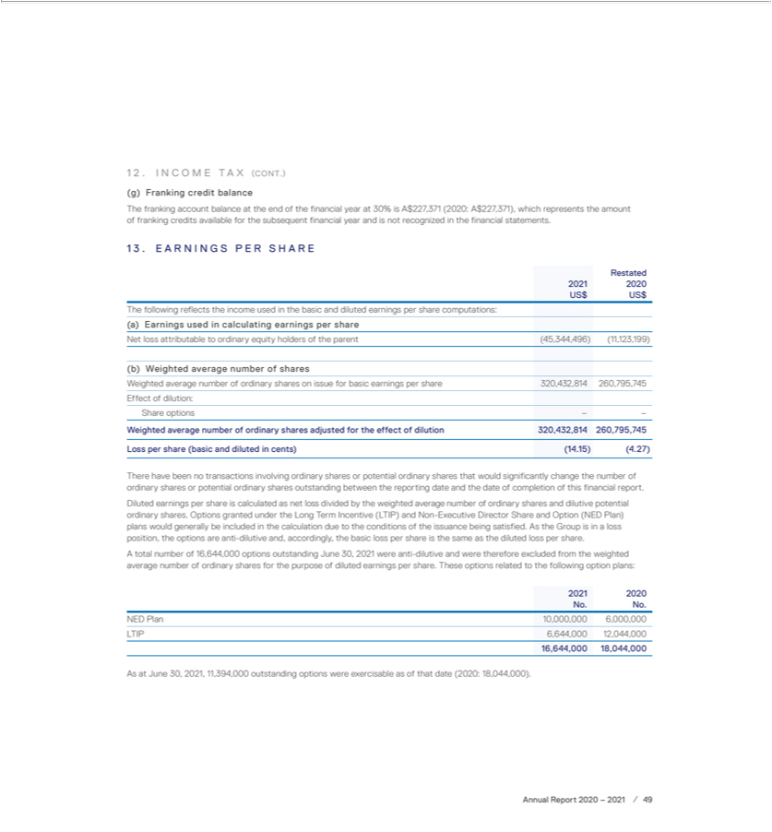

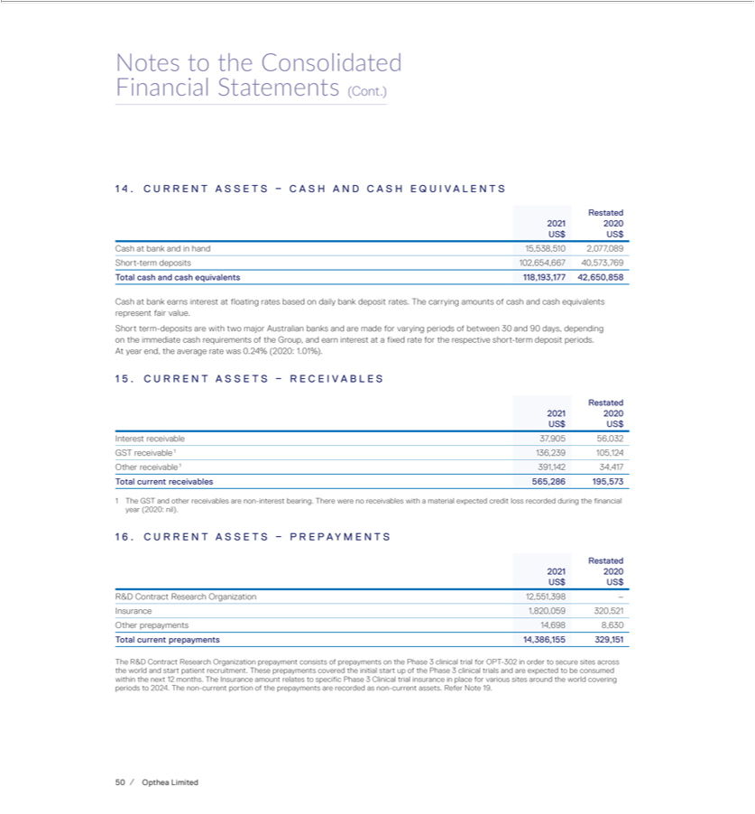

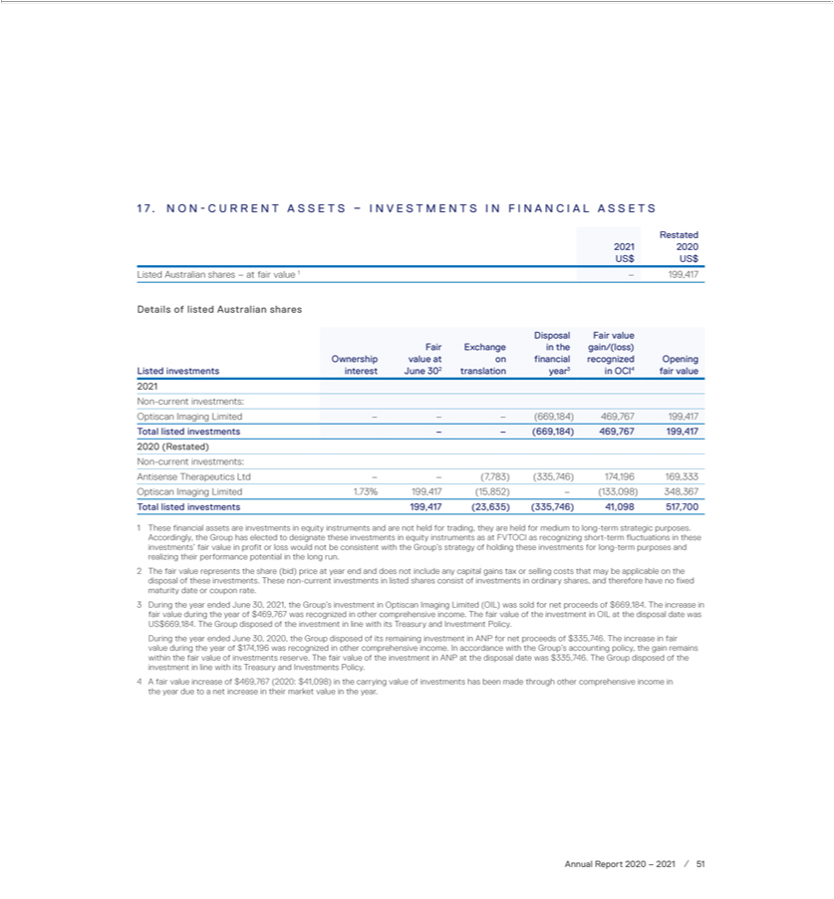

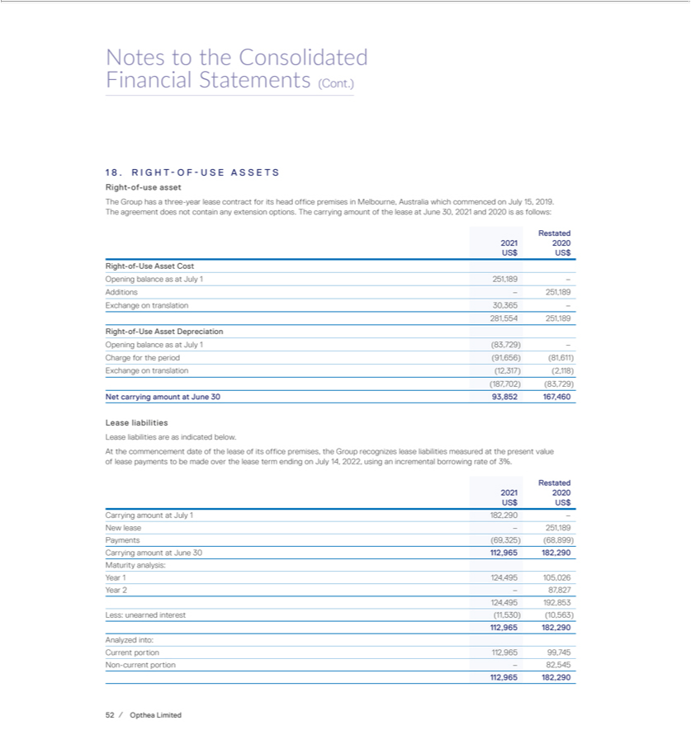

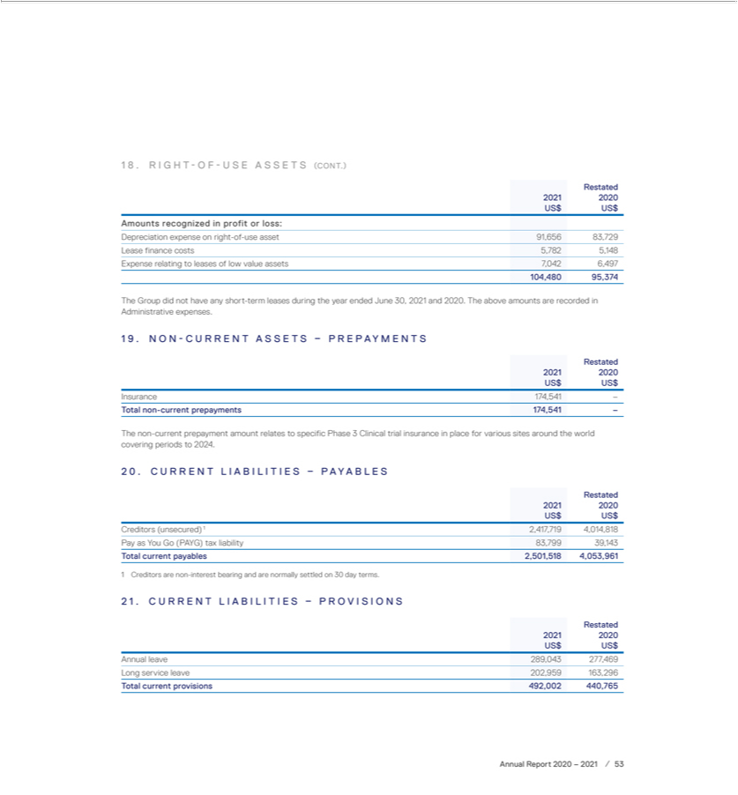

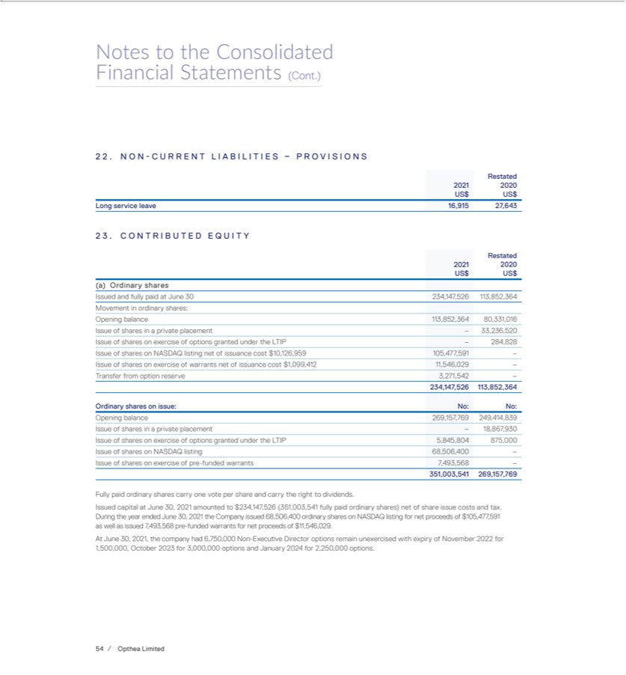

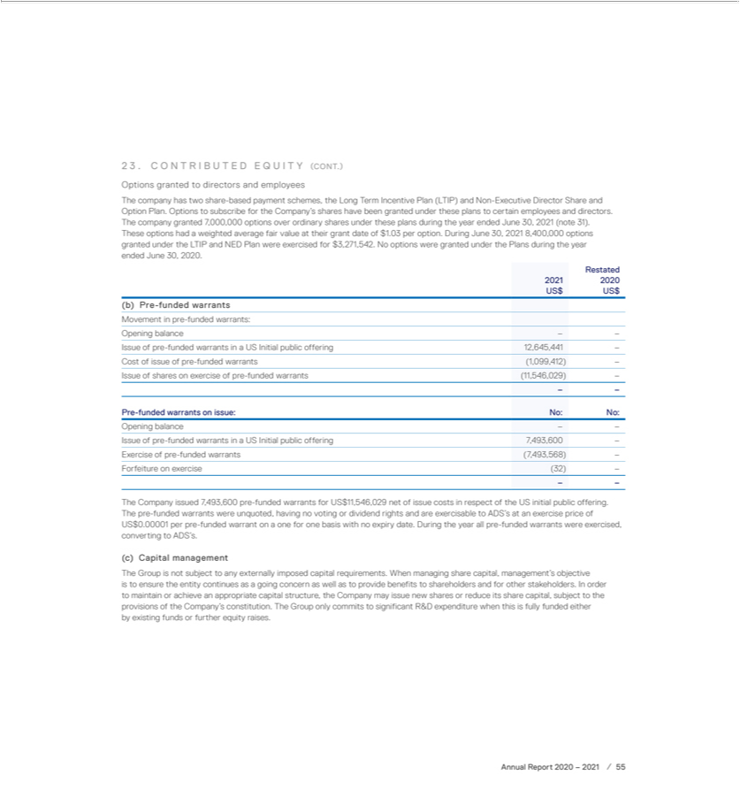



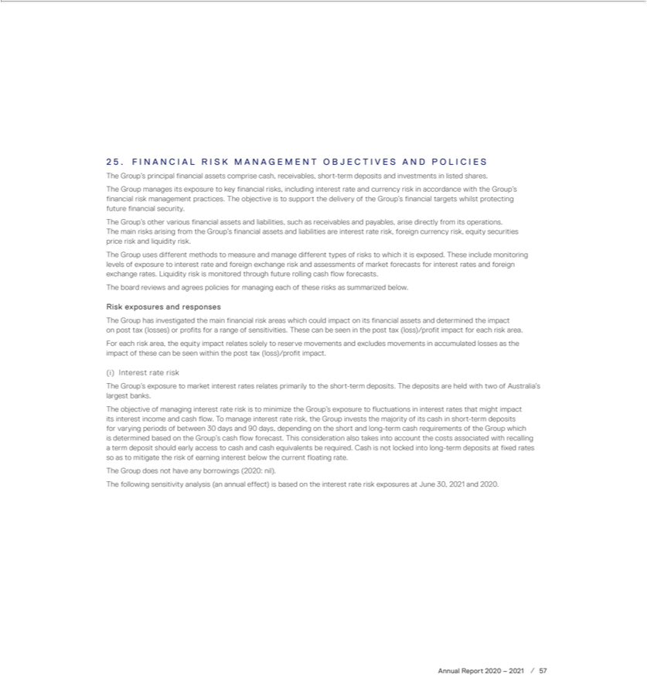

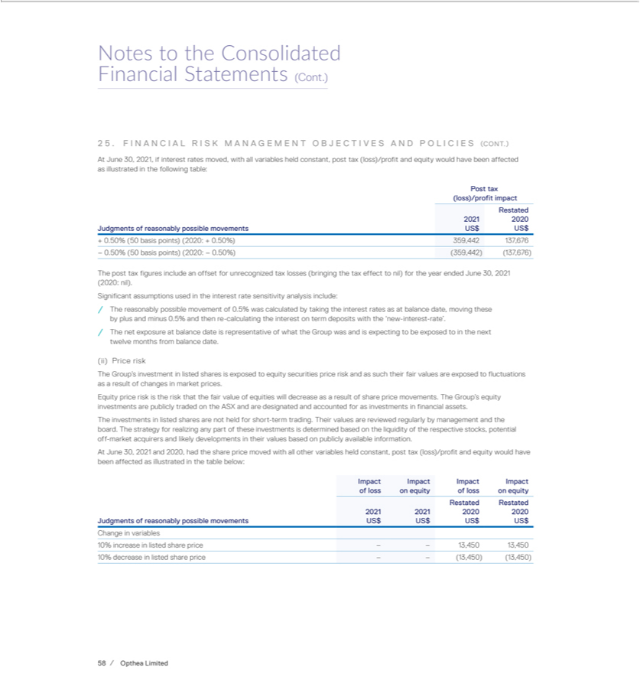

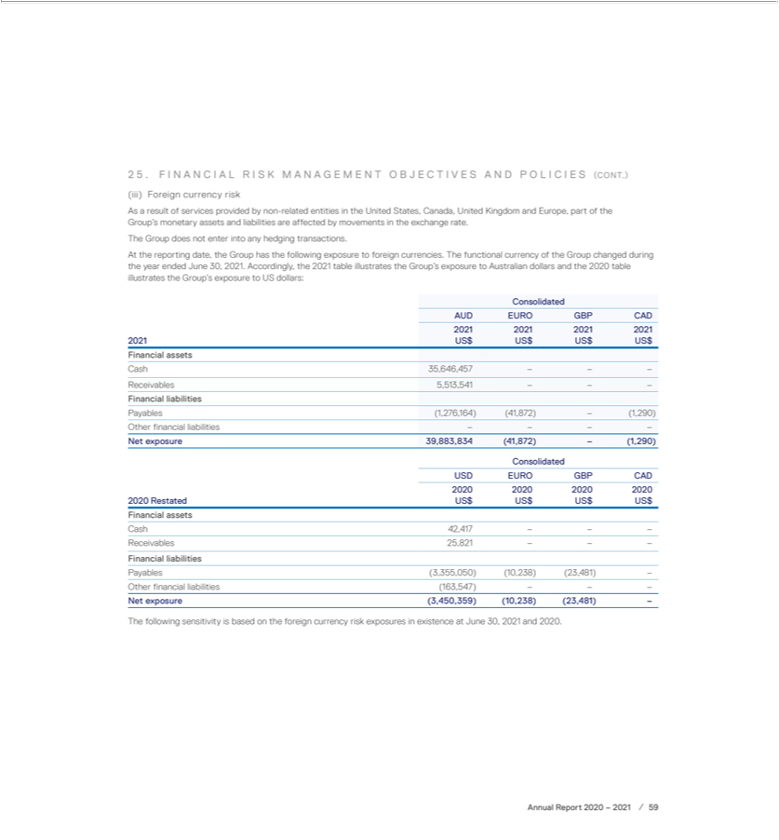

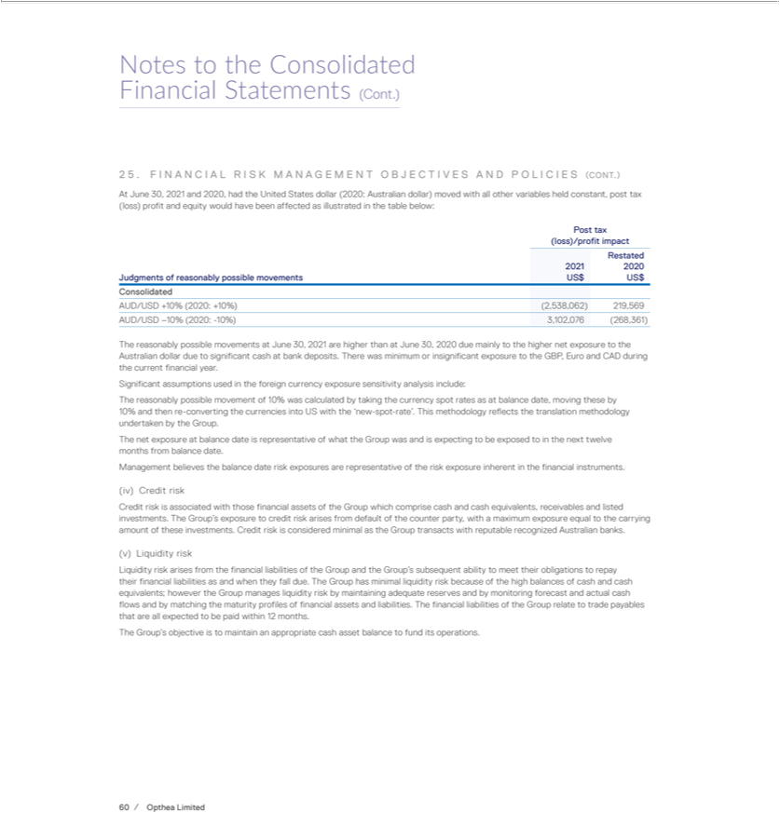

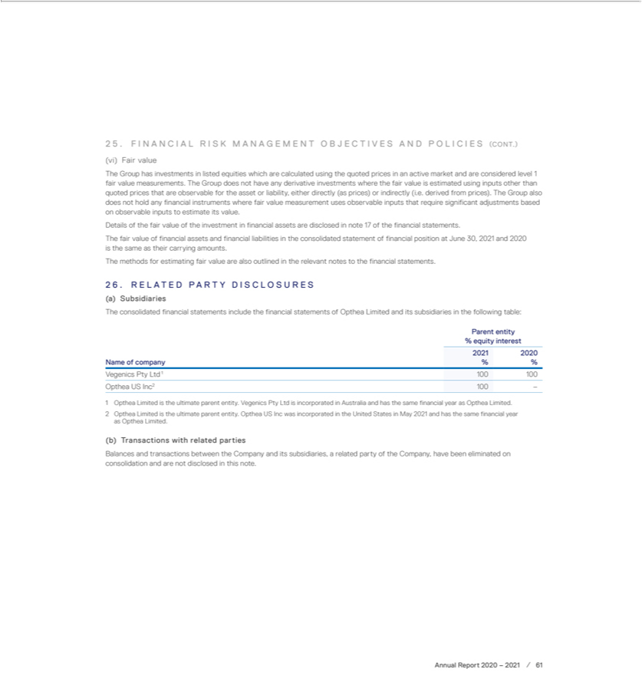

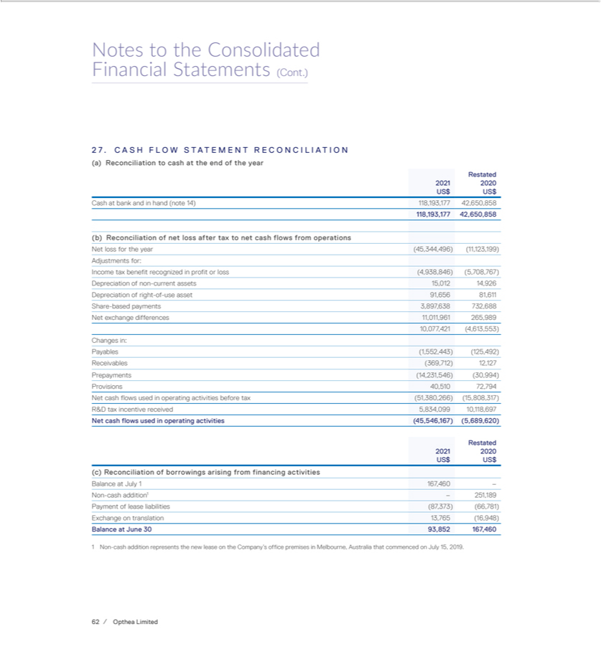

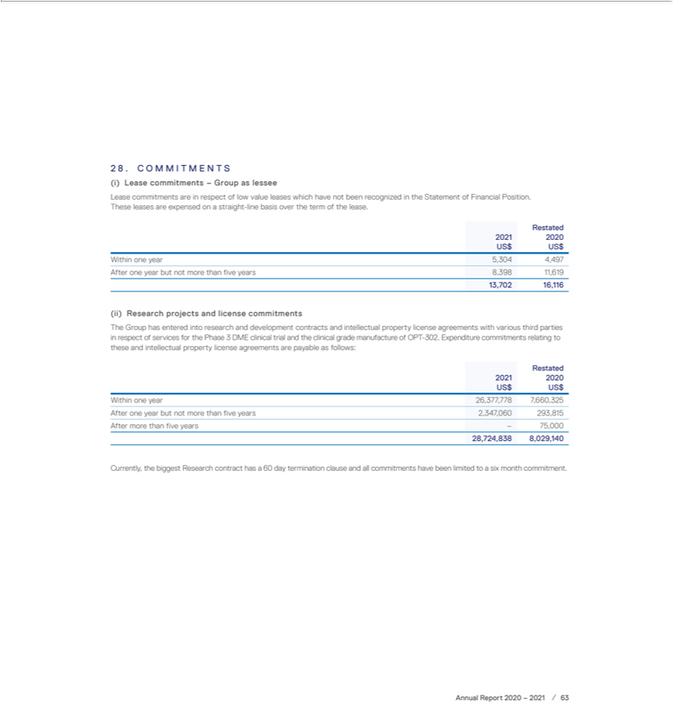

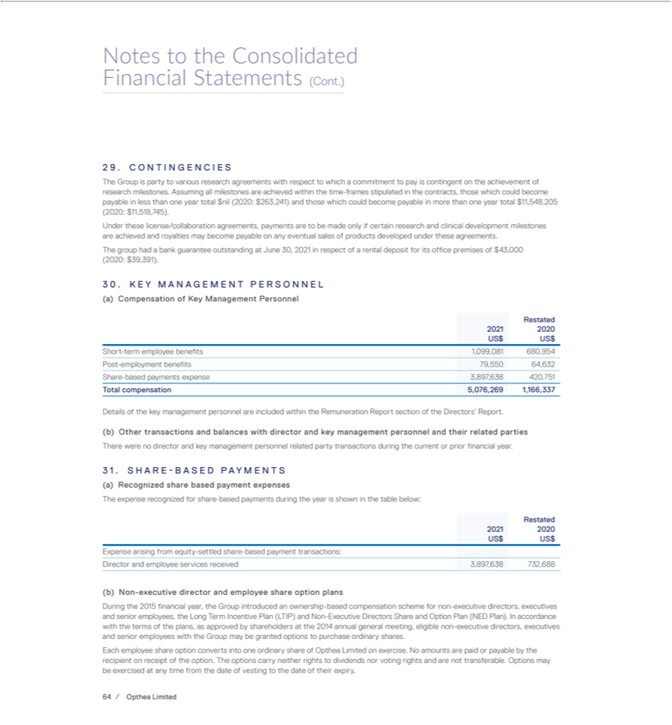

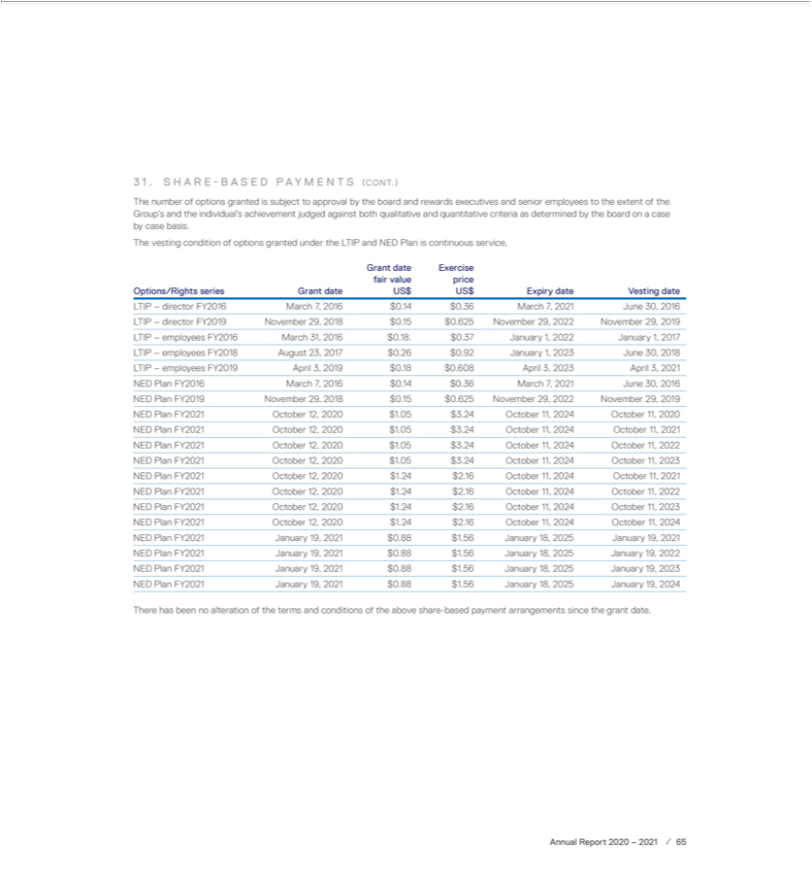

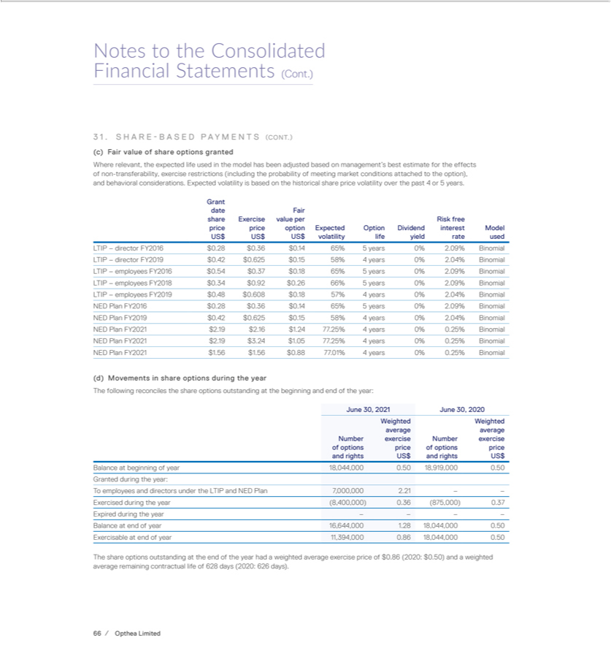

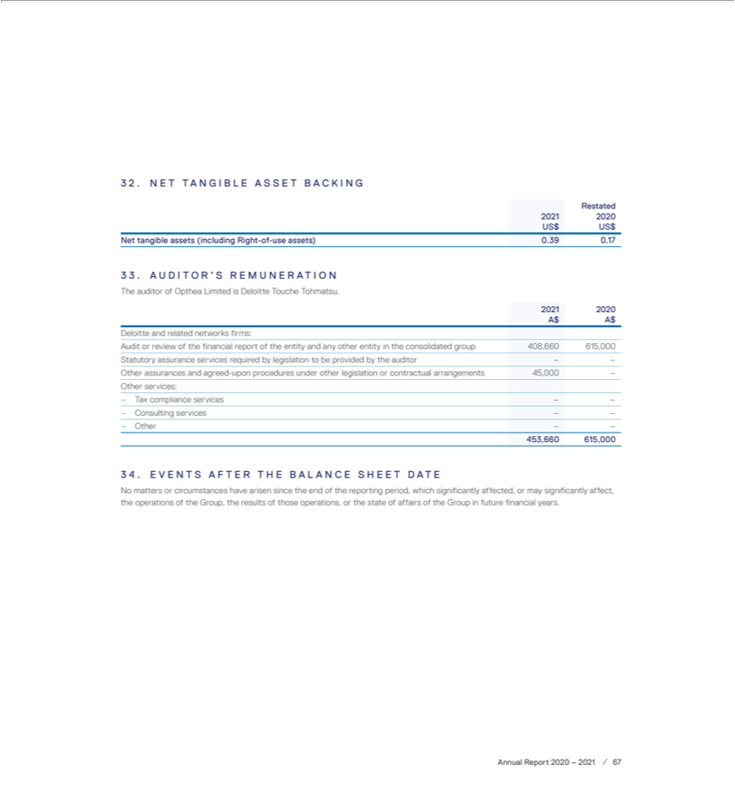

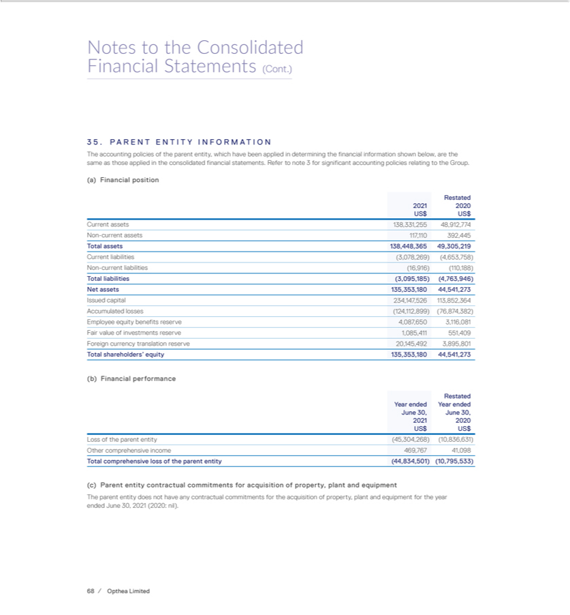



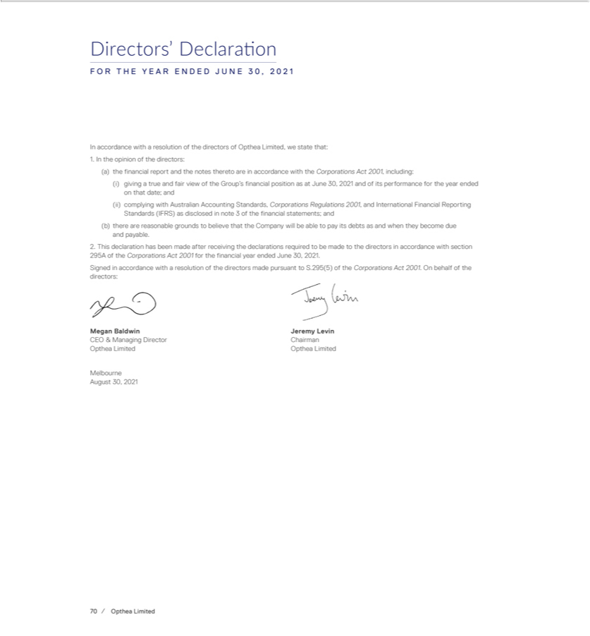





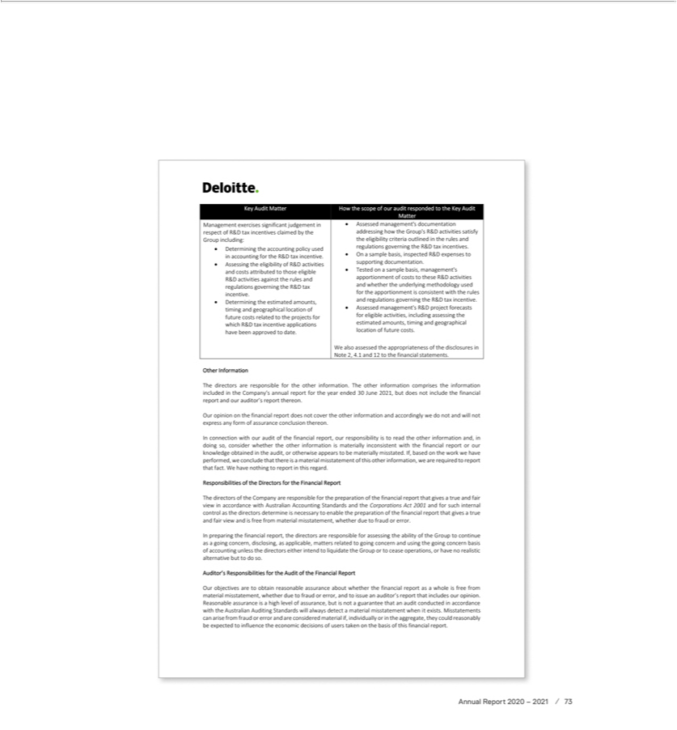





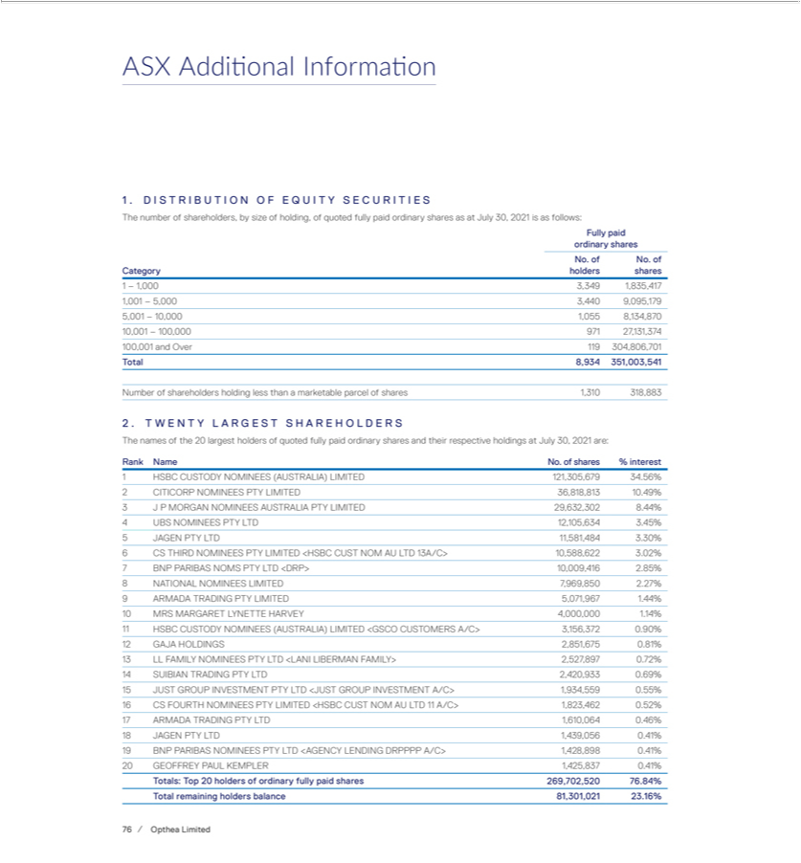

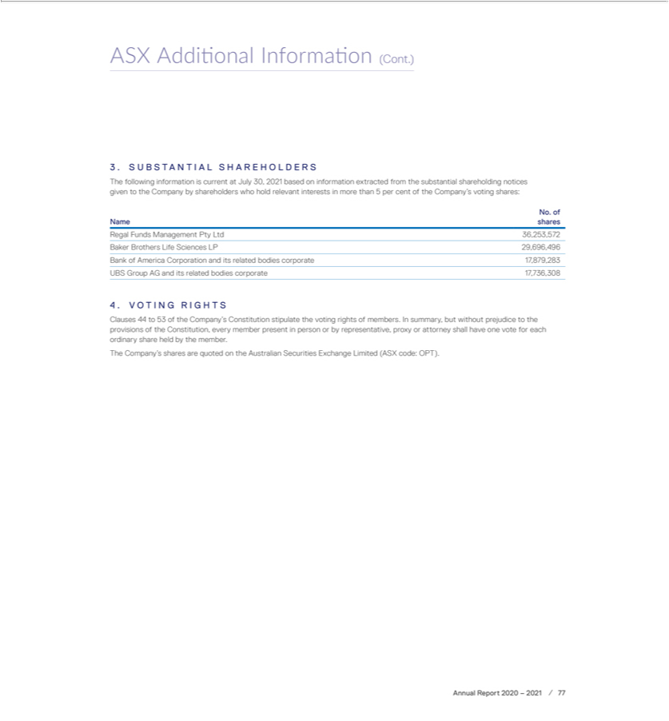



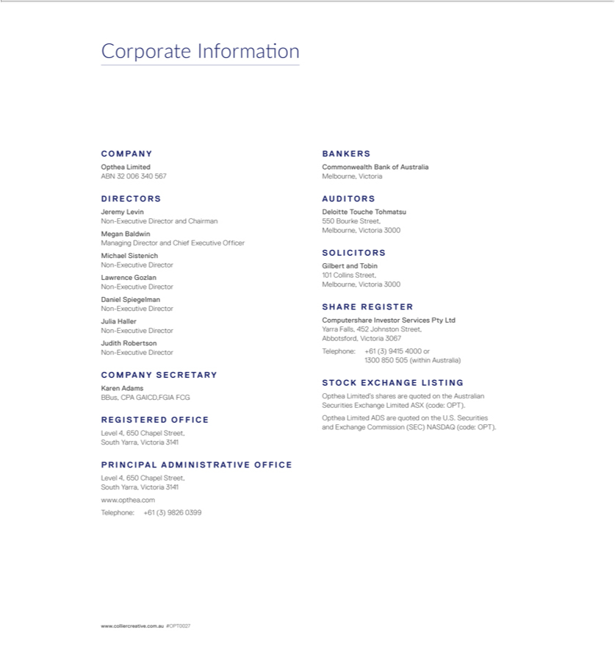

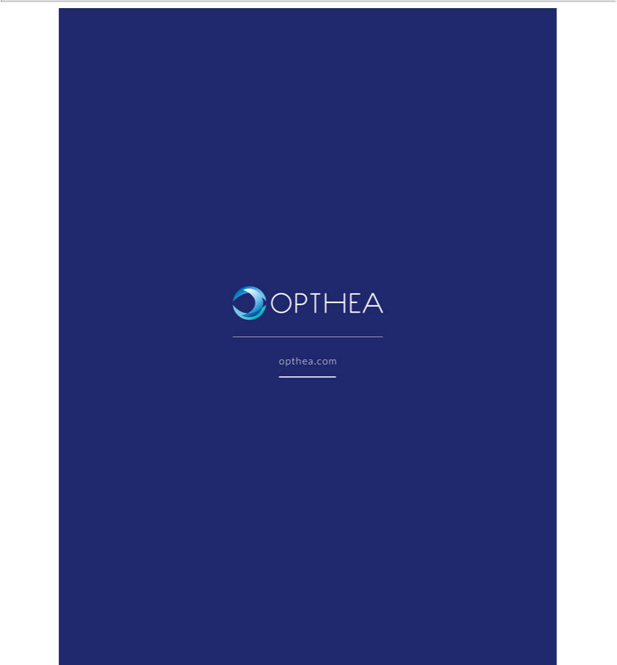

Exhibit 99.3


